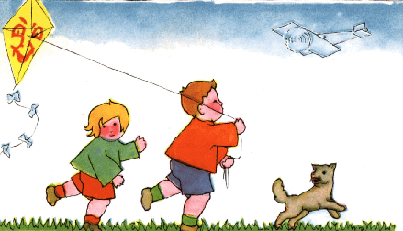
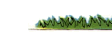
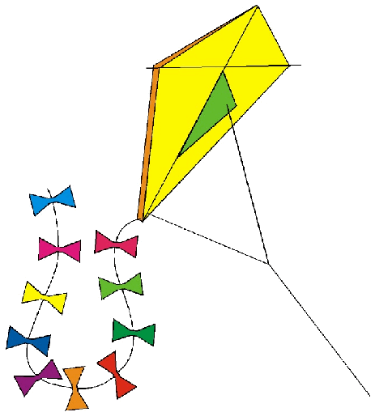


Volume 1 (Click to change text) ( Name) School
March 2010


A portion of Tony Pope’s Ode to Green Eggs and Ham (the book turns 50 years old this year!)

Green Eggs & Ham, Green Eggs & Ham!
I do so like Green Eggs & Ham!
I would read it here or there,
Say, I would read it anywhere!

Would you, Could you?
Read the book?
Could you? Would you?
Read the book?

From Pre/K to 12
From Z to A
Would you? Could you?
Read it today?
Would you? Could you?
Read the book?
In fifty different places?
You can if you look!

So as Green Eggs & Ham
Turns fifty this year…
Read it, Read It, and Read it I say…
As we celebrate Green Eggs & Ham’s B-I-R-T-H Day!

Tony L. Pope
McHenry Primary School

Reader's Oath
I promise to read
Each day and each night.
I know it's the key
To growing up right.
Read the rest of the oath on: http://www.nea.org/grants/13770.htm

.
.

The whole world opened to me when I learned to read. ~
Mary McLeod Bethune. 

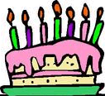

Literary Birthdays
Dr. Seuss March 2
Web site
Leo Dillon March 2

Patricia MacLachlan March 3

Kenneth Grahame March 8

Keats, Ezra Jack March 11

Marguerite de Angeli March 14

Mitsumasa Anno March 20

Bill Martin, Jr. March 20

Anna Sewell March 30

Find Additional Birthdays here.


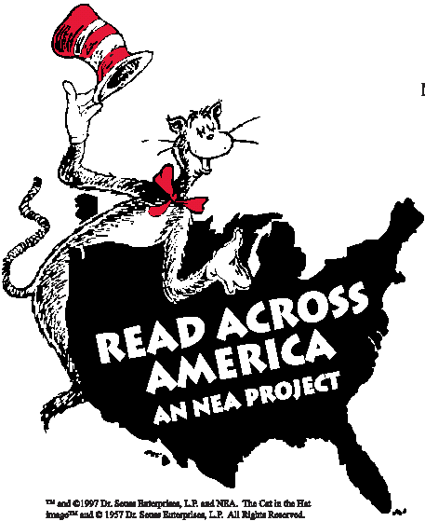

March 2 is
Read Across America
Day (and Dr. Seuss’s
birthday)

NEA's Read Across America
brings young readers adventures that will have them reading across the country.
Click below for more information on events and celebrations,
http://www.nea.org/readacross

Click here for Pledge to Participate:
http://www.nea.org/grants/2687.htm

Dr. Seuss’s web site:

http://www.seussville.com

Happy 15th Birthday GALILEO!
www.galileo.usg.edu (Ask your Media Specialist for the password)

