


Volume # (Click to change text) (Name) School October 2009



SAT Online!
The state of Georgia offers high school students free access to the SAT Online Prep Course developed by the College Board, the group that administers the SAT. This online course gives students access to virtual preparation exercises, review quizzes and several practice tests. The practice quizzes and tests, including the essay portion, are scored and feedback is given directly to the student.
Among Georgia's 2008 graduating seniors, the students who used the free SAT Prep Course scored significantly better on all portions of this important college entrance exam.



Expand your mind-
READ!

Noteworthy:

“


Americans go to school, public and academic libraries 50% more often than they go to the movies.
ALA

Literary Birthdays:

Wallace Stevens October 2

James Whitcomb Riley October 7

Oscar Wilde October 9

e.e.cummings October 14

Arthur Miller October 17

Eugene O’Neill October 17

Samuel Taylor Coleridge October 21

Pat Conroy October 26

Sylvia Plath October 27

Dylan Thomas October 27

Ezra Pound October 30

John Keats October 31

Katherine Paterson October 31

l

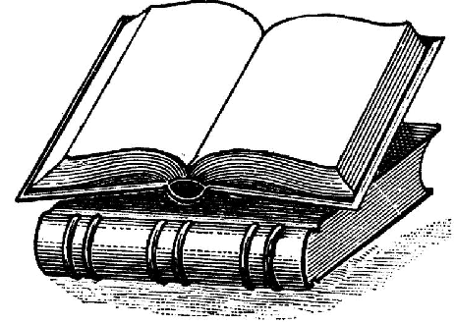



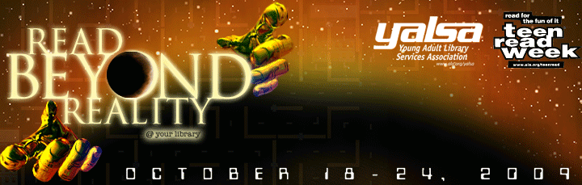

Teen Read Week is October 18-24.

This year's theme is Read Beyond Reality @ your library, which encourages teens to read something out of this world, just for the fun of it.

Georgia Peach Award for
Teen Readers
13 Reasons Why by Jay Asher

When Clay Jenson plays the cassette tapes he received in a mysterious package, he's surprised to hear the voice of dead classmate Hannah Baker. He's one of 13 people who receive Hannah's story, which details the circumstances that led to her suicide. 

