


Volume # (Click to change text) (Name) School October 2010

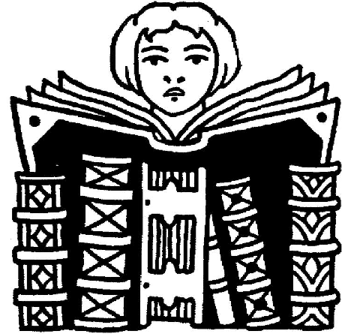

Jimmy Carter was born on October 1, 1924 and was awarded the Nobel Peace Prize on October 11, 2002.
You can read more about our Georgia President at:

http://www.jimmycarter.info/
http://www.nps.gov/jica/

http://www.whitehouse.gov/about/presidents/jimmycarter
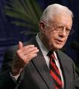

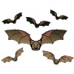

Expand your mind-
READ!

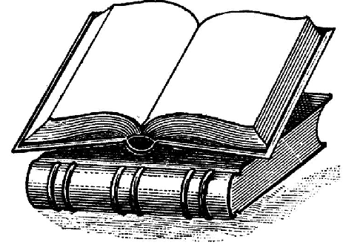

Noteworthy:

“


Americans go to school, public and academic libraries 50% more often than they go to the movies.
ALA

Literary Birthdays:

Wallace Stevens October 2

James Whitcomb Riley October 7

Oscar Wilde October 9

e.e.cummings October 14

Arthur Miller October 17

Eugene O’Neill October 17

Samuel Taylor Coleridge October 21

Pat Conroy October 26

Sylvia Plath October 27

Dylan Thomas October 27

Ezra Pound October 30

John Keats October 31

Katherine Paterson October 31

l

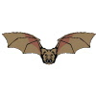

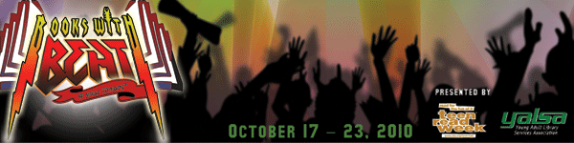

Teen Read Week is October 17-23.

This year's theme is Books With Beat @ your library, which encourages teens to read poetry, audiobooks, books about music, and more.


Carter Finally Gets It by Brent Crawford

Awkward freshman Will Carter endures many painful moments during his first year of high school before realizing that nothing good comes easily, focus is everything, and the payoff can be incredible.

Georgia Peach Award for Teen Readers

