


Volume # (Click to change text) (Name) School October 2011

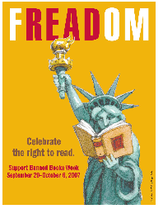

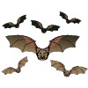

Expand your mind-
READ!

Noteworthy:

“

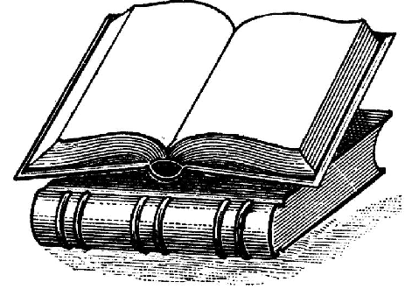



Americans go to school, public and academic libraries 50% more often than they go to the movies.
ALA

Literary Birthdays:

Wallace Stevens October 2

James Whitcomb Riley October 7

Oscar Wilde October 9

e.e.cummings October 14

Arthur Miller October 17

Eugene O’Neill October 17

Samuel Taylor Coleridge October 21

Pat Conroy October 26

Sylvia Plath October 27

Dylan Thomas October 27

Ezra Pound October 30

John Keats October 31

Katherine Paterson October 31

l

From the ALA website
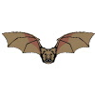

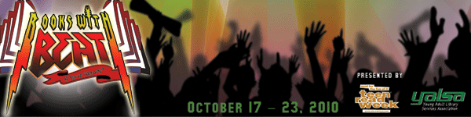

Teen Read Week is October 18-22.

.

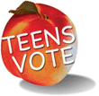
The purpose of the Georgia Peach Award is to highlight and promote the best current young adult literature for Georgia high school age students, to encourage young adults to read and to promote the development of cooperative school and public library services for young adults. Teens vote for their favorite books out of the year's top 20 nominees at their high schools and local public libraries

Bruiser by Neal Shusterman
Inexplicable events start to occur when sixteen-year-old twins Tennyson and Brontë befriend a troubled and misunderstood outcast, aptly nicknamed Bruiser, and his little brother, Cody.

Georgia Peach Award for Teen Readers

