
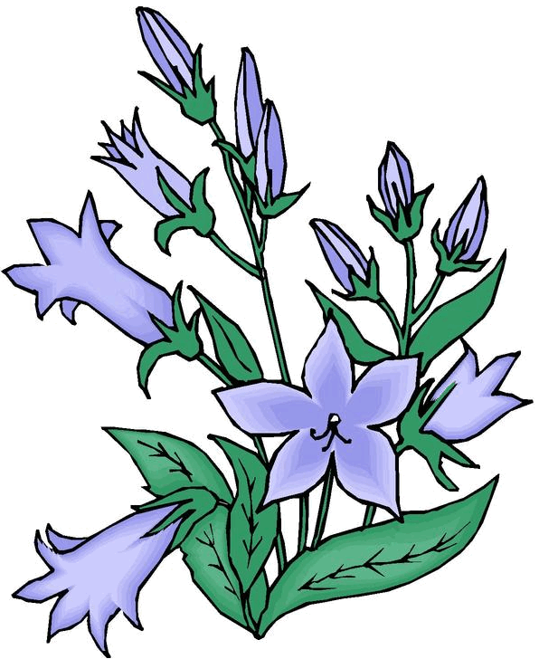

Volume (Click to change text) (Name) School April 2009

You know about the Newbery
and the Caldecott Award, but
do you know
about the Printz Award?

The Michael L. Printz Award is
an award for a book that exemplifies literary excellence in young adult literature. It is named for a Topeka, Kansas school librarian who was a long-time active member of the Young Adult Library Services Association.

This year’s Printz Award was given to Melina Marchetta for Jellicoe Road.
Haunted by the past, Taylor Markham reluctantly leads the students of the Jellicoe School in their secret territory wars against the Townies and the Cadets. Marchetta’s lyrical writing evokes the Australian landscape in a suspenseful tale of raw emotion, romance, humor and tragedy.
Melina Marchetta lives in Sydney, Australia, and is the award-winning author of two previous novels. A former high school teacher, she is recognized for the authenticity of her teen characters’ voices.



Worlds connect at your library!
National Library Week
April 12-18

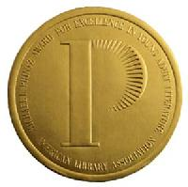

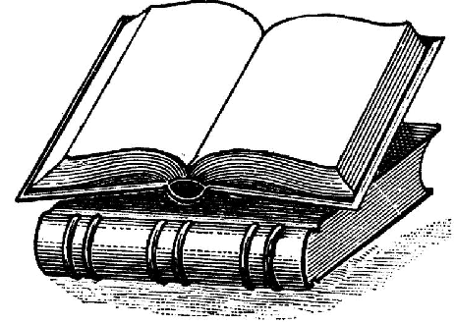
What’s Happening?



Featured book this month:

The state of Georgia offers high school students free access to the SAT Online Prep Course developed by the College Board, the group that administers the SAT. This online course gives students access to virtual preparation exercises, review quizzes and several practice tests. The practice quizzes and tests, including the essay portion, are scored and feedback is given directly to the student.

Among Georgia's 2008 graduating seniors, the students who used the free SAT Prep Course scored significantly better on all portions of this important college entrance exam.

www.gadoe.org/SATPrepClass.

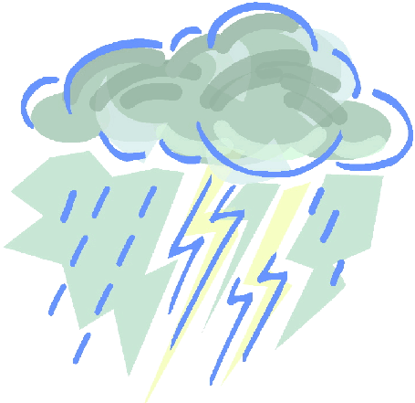
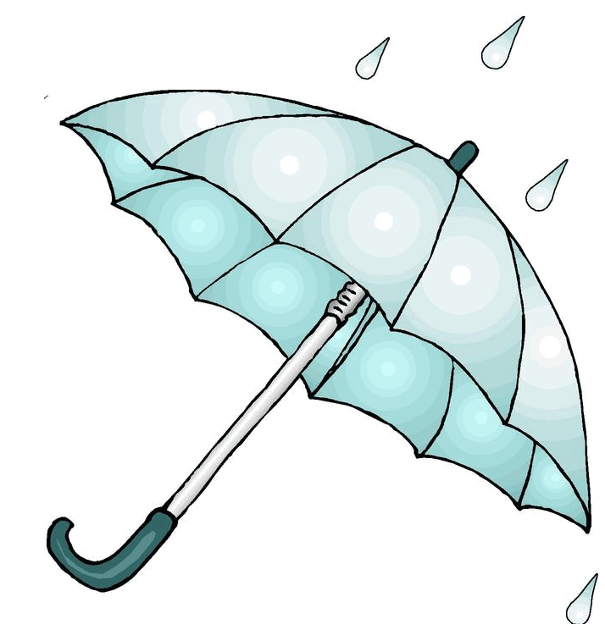

Literary Birthdays: 

Washington Irving ……….. April 3

Maya Angelou ..……………...April 4

Booker T. Washington …….. April 5

William Wordsworth ……….April 7

Gary Soto ……………………April 12

Thomas Jefferson ……….…..April 13

Eudora Welty..……………… April 13

Henry James ……………… April 15

Thornton Wilder ……………April 17

Charlotte Bronte …………….April 21

William Shakespeare ………. April 23

Harper Lee ……………. …April 28

National Poetry Month

l

Have you tried?



