
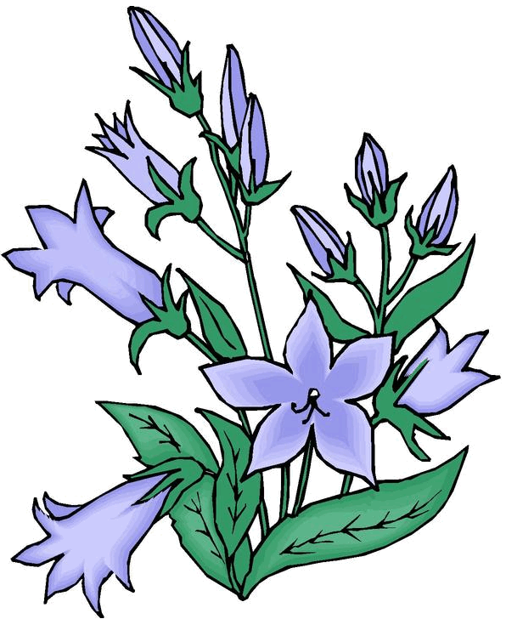

Volume (Click to change text) (Name) School April 2010

You know about the Newbery
and the Caldecott Award, but
do you know
about the Printz Award?

The Michael L. Printz Award is
an award for a book that exemplifies literary excellence in young adult literature. It is named for a Topeka, Kansas school librarian who was a long-time active member of the Young Adult Library Services Association.

This year’s Printz Award was given to Going Bovine by Libba Bray. The book is published by Delacorte Press, an imprint of Random House Children’s Books, a division of Random House

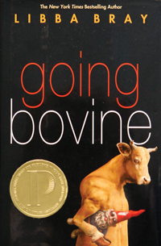
Cameron, a sixteen-year-old slacker, sets off on a madcap road trip along with a punk angel, a dwarf sidekick, a yard gnome and a mad scientist to save the world and perhaps his own life.

April is

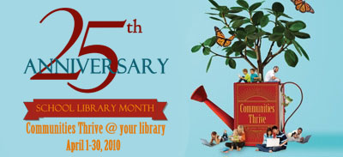

School Library Media Month!

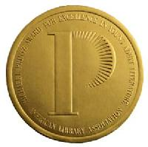

What’s Happening?


National Poetry Month

Library of Congress Poetry 180

NCTE's Classroom Notes +

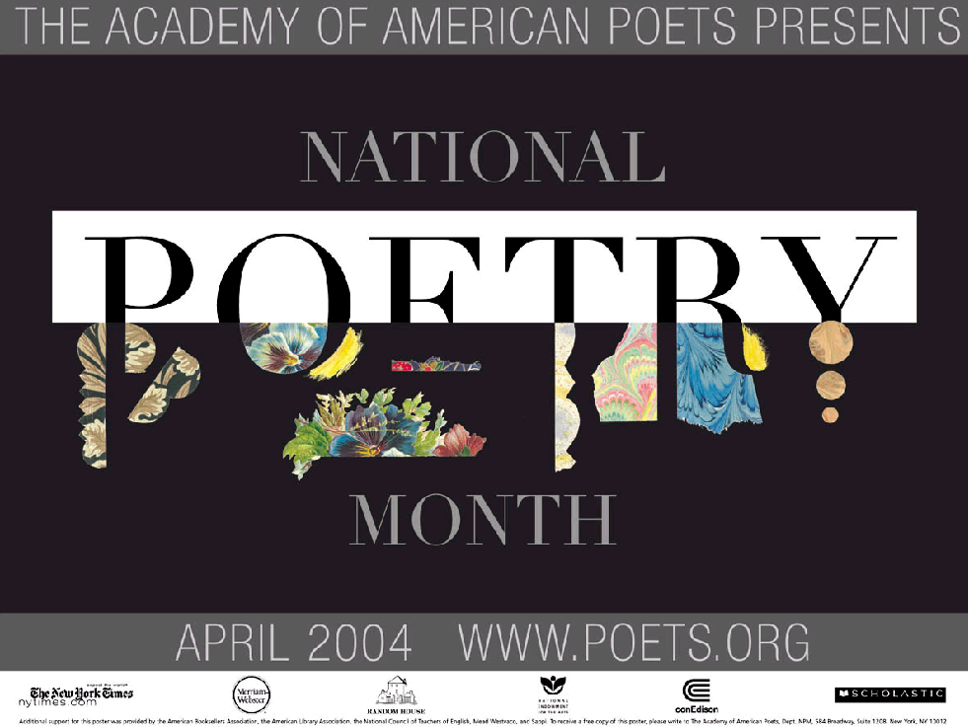

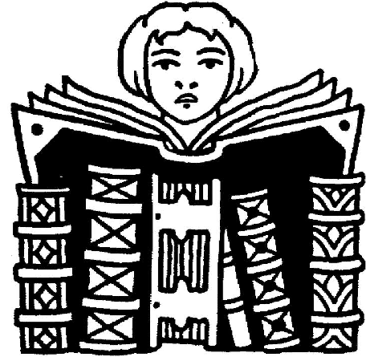

Featured book:

We have new books in our Library Media Center. Come check us out!
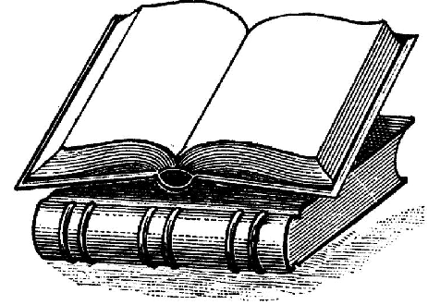

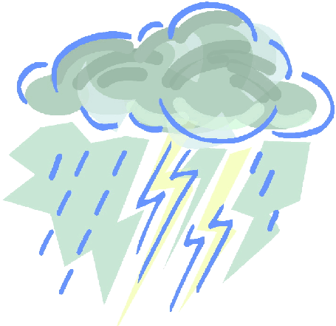
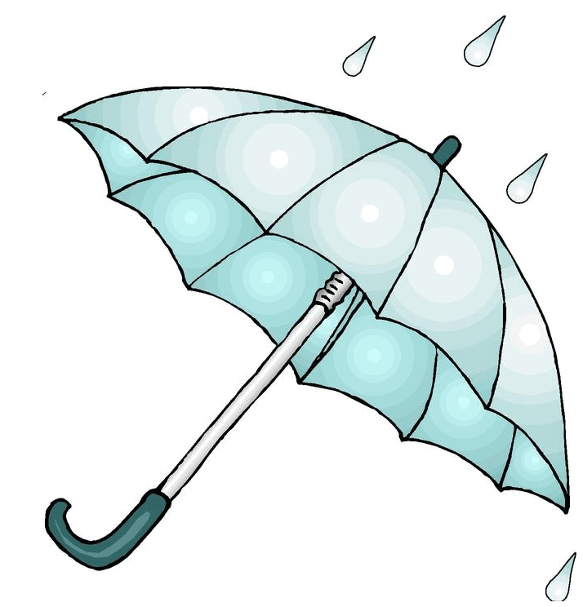

Literary Birthdays:

Washington Irving ……….. April 3

Maya Angelou ..……………...April 4

Booker T. Washington …….. April 5

William Wordsworth ……….April 7

Gary Soto ……………………April 12

Thomas Jefferson ……….…..April 13

Eudora Welty..……………… April 13

Henry James ……………… April 15

Thornton Wilder ……………April 17

Charlotte Bronte …………….April 21

William Shakespeare ………. April 23

Harper Lee ……………. …April 28


l

Have you tried?

