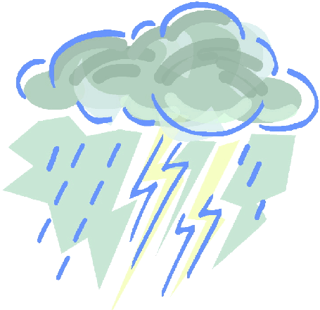



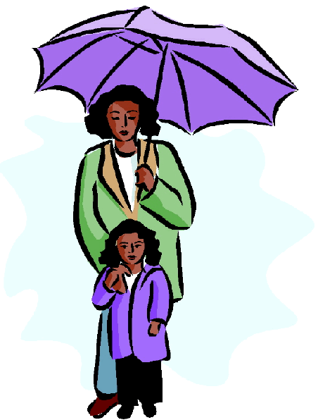

Volume 1 (Click to change text) ( Name) School
April 2011

Extra, extra, read all about it!

(Do you have a new book you want to promote? Do you have an old favorite that the students may not know about? Spotlight that book here.)

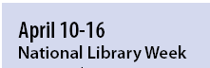
Do you have a public library card? Be sure to sign up for one so that you can read all summer!



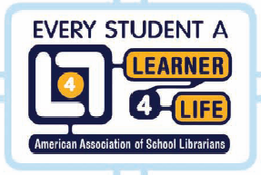


A Book

There is no frigate like a book
To take us lands away,
Nor any courser like a page

Of prancing poetry.

This traverse may the poorest take

Without oppress of toll;

How frugal is the chariot

That bears a human soul!

Emily Dickinson

Literary Birthdays

Hans Christian Anderson April 2
Ruth Heller April 2
Donald Carrick April 7

Trina Schart Hyman April 8
Beverly Cleary April12

Gary Soto April 12
Marguerite Henry April 13

Gertrude Chandler Warner April 16
Mitchell Sharmat April 18

Eileen Christelow April 22
Patricia Reilly Giff April 26
Ludwig Bemelmans April 27



Check out the fun and learning on the PBS Kids Site!


