
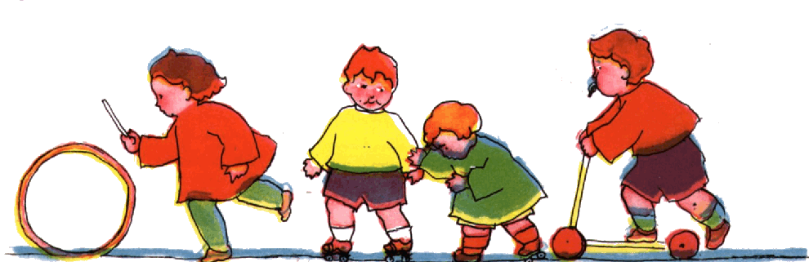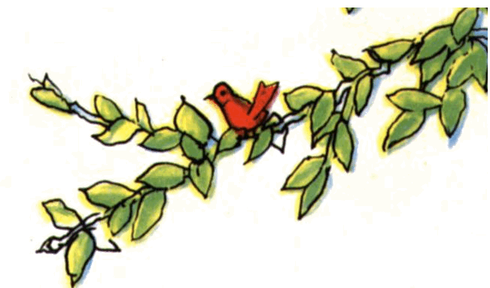



Volume 1 (Click to change text) ( Name) School August 2011

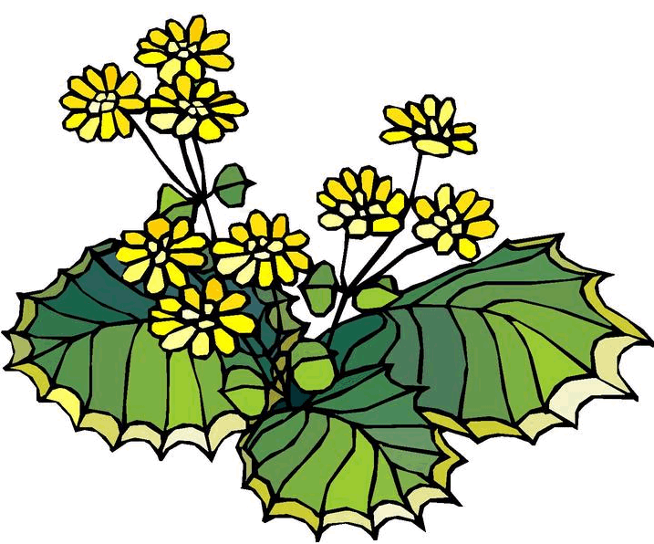
GALILEO (password available from your Library Media Specialist) has wonderful resources for the whole family….from PreK to adults.

Check out this valuable online library.
www.galileo.usg.edu

Reading Rocks!!!
Pick up a book today……..
(Click in any box to change or insert text.)

Did you participate in the
Summer Reading Club at the
public library?
Let your teacher know and
she will inform the Library Media
Specialist.






Literary Birthdays:
James Howe August 2
Betsy Byars August 7
Marjorie K Rawlings August 8

Jose Aruego August 9

Seymour Simon August 9

Joanna Cole August 11

Brinton Turkle August 13

Vicki Cobb August 19

Ogden Nash August 19

Tasha Tudor August 28

Karen Hesse August 29

Virginia Lee Burton August 30

Donald Crews August 30

A nominee for the 2011-2012 Georgia
Children’s Picture
storybook Award



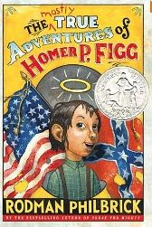
A nominee for the 2011-2012 Georgia Children’s Book Award

Ivan the Terrier by Peter Catalanotto

A high-spirited terrier creates mayhem in the fairy-tale world as an unseen narrator tries to tell a series of bedtime stories. "Once upon a time there were three billy goats named Gruff," the narrator begins, but stops short when Ivan bursts onto the scene with an enthusiastic "Arf! Arf! Arf!" After chasing away the goats, he moves on to disrupt the lives of the three bears, the three little pigs, and the gingerbread boy. The noisy pup sneaks into each story, refusing to calm down despite the narrator's increasingly strident admonitions. At last, the storyteller gives up and in one final effort intones, "There once was a little dog named Ivan." But the terrier wanders away to fall asleep in his doggie bed, probably worn out from all of his mischief.

The mostly true adventures of
Homer P. Figg by Rodman
Philbrick.
When his older brother gets conscripted into the Union Army, Homer runs away from his uncle. He sets out after Harold but has multiple misadventures along the way. He survives thanks to courage, luck, and his talent for telling lies when needed, since "old Truth ain't nearly as useful as a fib sometimes." Homer relates his own adventures in colorful language as he crosses paths with con men, rogues, and scoundrels of various types.

