



Volume 1 (Click to change text) ( Name) School
December 2009


Extra, extra, read

all about it!

Jean De Brunhoff—1899-1937

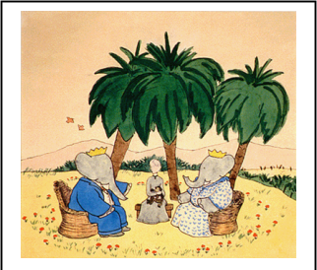
Check out this Kid Internet Browser KidZui has been around for a year but just released a new version. The basic version is free.
KidZui, the Internet for kids, is the leader in making the Internet big, fun, and safe for children ages 3-12.
It will allow children to safely and independently search, share and discover more than 2 million parent and teacher approved websites, pictures, games and videos. KidZui’s purpose is to keep kids safe online, empower their curiosity, and engage parents with their kids’ interests (through weekly parental emails and parental controls).
KidZui is backed by the Scholastic Corporation and other organizations.

Jean De Brunhoff was a French author who is sometimes referred to as the “father of picture books.”
He wrote the Babar books. Have you read them?





Picture from http://antiquesandthearts.com/Antiques/TradeTalk/2008-09-23__12-44-30.html

Literary Birthdays

Jan Brett December 1

David Macaulay December 2

Jean de Brunhoff December 9

Joel Chandler Harris December 9

Mary Norton December 10

Eve Bunting…………… December 19

Michael Berenstain… …..December 21

Jerry Pinkney December 22-

Mercer Mayer December 30

Just the Facts, Ma’am!
Find all sorts of facts about the state of Georgia (and the other 50 states in the union, as well) at the International Public Library’s Stately Knowledge area.
http://www.ipl.org/div/kidspace/stateknow/ga1.html


Ability may get you to the top, but it takes character to keep you there. ~ John Wooden

