

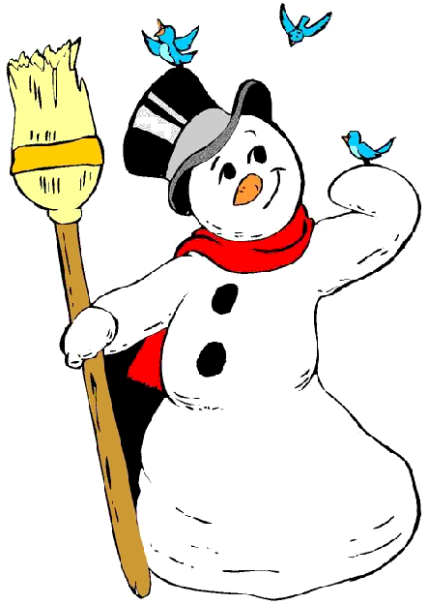

Volume 1 (Click to change text) ( Name) School
December 2011


Reading Rocks!!!
Pick up a book today……..
(Click in any box to change or insert text.)
Internet Safety Tip

Remember never to give out personal information such as your name, home address, school name, or telephone number in a chat room or on bulletin boards. Also, never send a picture of yourself to someone you chat with on the computer without your parent's permission.

Holiday Websites

Hanukkah

Christmas

December Holidays

Kwanzaa

The Young Georgia Authors Competition 2010-2012
Information is posted on the Georgia Department of Education English Language page

Scroll to the bottom of the page, and you will see the following documents:
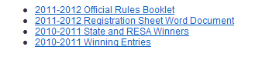

Please note the deadline for entries this year is in April 13, 2012.
The YGA competition is for students in grades K through 12.



December Birthdays!

Jan Brett December 1

David Macaulay December 2

Jean de Brunhoff December 9

Joel Chandler Harris December 9

Mary Norton December 10

Eve Bunting…………… December 19

Michael Berenstain… …..December 21

Jerry Pinkney December 22-

Mercer Mayer December 30

Stately Facts
Find all sorts of facts
about the state of
Georgia (and the other
49 states in the union,
as well) at the International Public Library’s Stately Knowledge area.

http://www.ipl.org/div/stateknow/ga1.html


