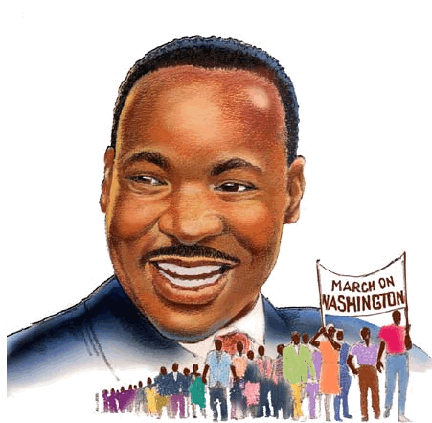

Volume 1 (Click to change text) (Name) School February 2011



Did you hear about what is going on in (insert teacher’s name) ?

Spotlight a teacher and/or the students.

One legend contends that Valentine was a priest who served during the third century in Rome. When Emperor Claudius II decided that single men made better soldiers than those with wives and families, he outlawed marriage for young men — his crop of potential soldiers. Valentine, realizing the injustice of the decree, defied Claudius and continued to perform marriages for young lovers in secret. When Valentine's actions were discovered, Claudius ordered that he be put to death.

Check out these websites!
African American Artists

African American Inventors

Harlem Renaissance

Valentine’s Day




Literary Birthdays:

Langston Hughes February 1

James Joyce February 2
Sidney Lanier February 3

Charles Dickens February 7

Sinclair Lewis February 7

Kate Chopin, February 8

Alice Walker February 8

Toni Morrison February 18

Carson McCullers February 19
Amy Tan February 19
W.H. Auden February 21
W.E.B. DuBois February 23

John Steinbeck February 27
Henry Longfellow February 27





Come see our new
titles!


The 2011 Newbery Award


The 2011 Newbery Medal winner is Moon over Manifest by Clare Vanderpool. The town of Manifest is based on Frontenac, Kan., the home of debut author Clare Vanderpool’s maternal grandparents. Vanderpool was inspired to write about what the idea of “home” might look like to a girl who had grown up riding the rails. “Vanderpool illustrates the importance of stories as a way for children to understand the past, inform the present and provide hope for the future,” said Newbery Medal Committee Chair Cynthia K. Richey.

