




Volume 1 (Click to change text) ( Name) School
January 2011

Have you read this new book?

(Click in any box to change or insert text.)

Internet Safety tips from the FBI:
Do not meet someone or have them visit you without the permission of your parents.
Tell your parents right away if you read anything on the Internet that makes you feel uncomfortable.
http://www.fbi.gov/kids/k5th/safety2.htm

Go to this fabulous website!
Did you know? 
The official state amphibian of Georgia is the green tree frog.



Literary Birthdays

Jean Little January 2
Jacob Grimm January 4
Vera Cleaver January 6
Robert C. O’Brien January 11
Clement Hurd January 12
Richard Jesse Watson January 15
Janet Stevens January 17

Raymond Briggs January 18
A.A. Milne January 18
Huck Scarry January 21

Lewis Carroll January 27
Rosemary Wells January 29
Lloyd Alexander January 30

Caldecott Honor Book Red Sings from Treetops: A Year in Colors, illustrated by Pamela Zagarenski, written by Joyce Sidman,
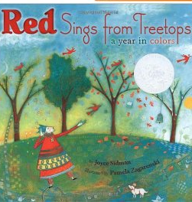

Great Web Sites for Kids from the American Library Association
Find great information on animals, literature and language, sciences, math, history, social sciences and more.


Computer illustration and mixed-media paintings on wood combine rich textures, intriguing graphic elements, stunning colors and stylized figures to reward attentive readers with a visually exciting interplay of poetry and illustration.

