



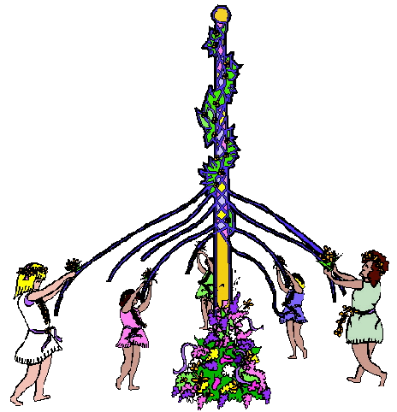

Volume 1 (Click to change text) ( Name) School
May 2010

Reading Rocks!!!
Pick up a book today……..

(Click in any box to change, delete or insert text.)

Extra, extra, read all about it!

Even students past the "picture book" stage love some of these birthday author's classics!

Goodnight Moon by Margaret Wise Brown
Harpercollins ISBN: 0060207051
Frederick by Leo Lionni
Knopf; Reissue edition ISBN: 0394810406
Frog & Toad Are Friends by Arnold Lobel
Harpercollins ISBN: 0064440206

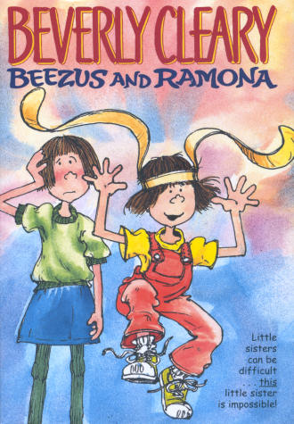




“Children and teachers need library resources – especially books - and the expertise of a librarian to succeed. Books, information technology, and school librarians who are part of the schools’ professional team are basic ingredients for student achievement,”
Laura Bush, Former First Lady & librarian

Literary Birthdays

.
Leo Lionni May 5

William Pene Du Bois May 9

James M. Barrie May 9

Christopher Paul Curtis May 10

Peter Sis May11

L. Frank Baum May 15

Arnold Lobel May22

Margaret Wise Brown May 23

Joyce Carol Thomas May 25

Eleanor Coerr May 29

The movie comes to theatres on July 23



Get the Kids Reading
With These Author Sites!
Share some Web sites that will keep kids reading this summer! Favorites such as Ramona Quimby’s Beverly Cleary, Berlioz the Bear’s Jan Brett, and Tomie DePaola. This amazing ALA resource provides Internet links to dozens of authors and illustrators, all annotated and child-safe. Create a summer calendar with your favorites or simply make a list or link available.

Be an advocate for your Library!
Save America's Libraries
1. Stay informed about advocacy activities of
the ALA and your state association.
2. Let the public, legislators and colleagues
know what great things the library offers!
3. Encourage library users to share their
stories. Make it easy to share success
stories- provide these "Peach of a library"
cards at the desk for quick responses.
Then display/send to legislators.



