
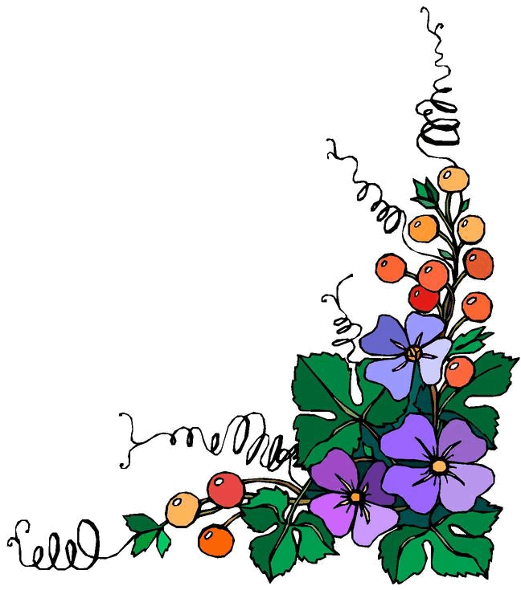

Volume 1 (Click to change text) (Name) School May, 2010

2009 Winner of the Peach Award for Teen Readers The Hunger Games by Suzanne Collins
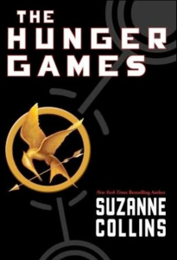

This month’s featured title:



Awkward freshman Will Carter endures many painful moments during his first year of high school before realizing that nothing good comes easily, focus is everything, and the payoff can be incredible.

Literary Birthdays: 

William Inge May 3

Orson Welles May 6

Robert Browning May 7

Archibald MacLeish May 7

Gary Snyder May 8

Christopher Paul Curtis May 10

Dante Alighieri May 14

Paul Zindel May 15

Katherine Anne Porter May 15

Randall Jarrell May 16

Gary Paulsen May 17

Alexander Pope May 21

Arthur Conan Doyle May 22

Ralph Waldo Emerson May 25

Raymond Carver May 25

Rachel Carson May 27

G. K. Chesterton May 29

Countee Cullen May 30

Walt Whitman May 31



According to a research study, if we can
encourage our students to read 5-8 books
over the summer that:
1. they are interested in
2. are on their Lexile level

the effects will be the same as going
to summer school. Encourage
your student to use the public library
this summer.

The "Find a Book" website on the Lexile webpage can help parents and students find books that meet the two criteria above.
http://www.lexile.com/findabook/

It is helpful to have your child’s Lexile measure, but the Lexile number is not required.

You and your child can choose areas of interest and the Lexile website will suggest books and even tell you (based on your IP computer address) the nearest public library where you can find the books.
Happy Reading!

