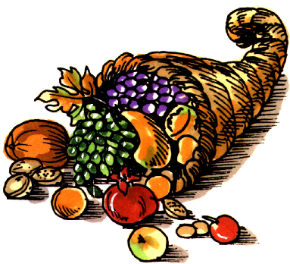


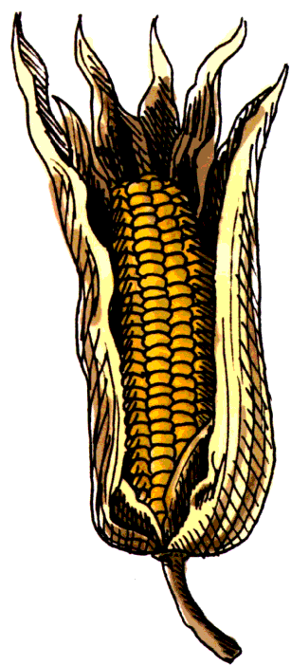

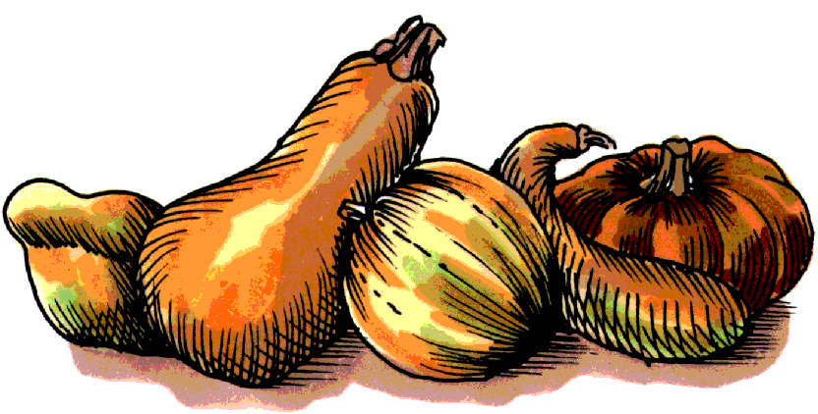

Volume (Click to change text) ( Name) School November 2010


Reading Rocks!!!
Pick up a book today……..

(Click in any box to change or insert text.)

Reading Champs!

Extra, extra, read

all about it!

Check out the 2010 Children’s Choices booklist from the International Reading Association and the Children’s Book Council. Some choices this year include:

Grades K-2
Being a pig is nice: a child’s eye view of manners by Sally Lloyd-Jones

Grades 3-4
Crow Call by Lois Lowry

Grades 4-5
Extra credit by Andrew Clements

Find the entire list here.

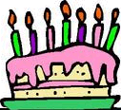
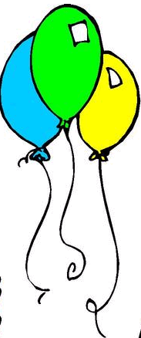
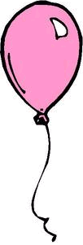

What’s Happening?

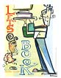

Literary Birthdays

Nathaniel Benchley November 13

Robert Louis Stevenson November 13

William Steig November 14

Marc Brown November 25

Tomi Ungerer November 28

Madeleine L’Engle November 29

C.S Lewis November 29

Margot Zemach November 29

Charles Schulz November 29

One of the greatest gift adults can give to their offspring and to their society is to read to children. ~ Carl Sagan

Who is Carl Sagan? Use GALILEO to do research on this person.

There are many little ways to enlarge your child’s world. Love of books is best of all. ~ Jacqueline Kennedy

