



Volume 1 (Click to change text) (Name) School November 2010


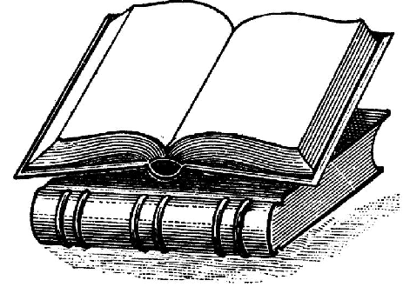


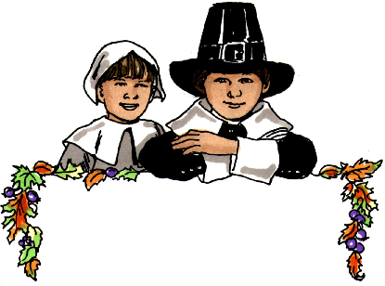

Expand your mind-

Looking towards the future? Visit the Internet Public Library’s Career Choices site. Designed for teens trying to figure out how to succeed!

Work your way from Career Choices to Career Biographies and finish in Career Preparation. It’s never too early to start planning

http://www.ipl.org/div/pfarch/entry/81352

Noteworthy:
(Click in any box to change or insert text.)



Literary Birthdays:

Nicholasa Mohr November 1

Sterling North November 4

Armstrong Sperry November 7

Bram Stoker November 8
Dracula (Online book)

Robert Louis Stevenson November 13

Elizabeth George Spear November 21

Madeleine L’Engle November 29

Mark Twain November 30

l

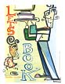



Outstanding Books for College
Bound & Lifelong Learners
:
Let Me Play: The Story of Title IX: The Law That Changed the Future of Girls in America by Karen Blumenthal.

The Power of Myth by Joseph Campbell and Bill Moyers

Feed by M.T.Anderson, M.T.

The Race to Save the Lord God Bird by Phillip Hoose
Find more suggestions at www.ala.org/yalsa/booklists/obcb


Have you tried?

