
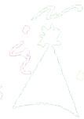



Volume 1 (Click to change text) ( Name) School
January 2012

Did you know? 
The official state amphibian of Georgia is the green tree frog.

You can learn more about Georgia at The New Georgia Encyclopedia and The Digital Library of Georgia websites on GALILEO.

These resources had over 21 million hits in 2010!

www.galileo.usg.edu (Ask your Media Specialist for the password)


Caldecott Medal 2011 goes to Erin E. Stead for 'A Sick Day for Amos McGee'
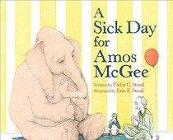
Erin E. Stead has won the Caldecott Medal for 2011 for her work on the book, A Sick Day for Amos McGee written by Philip C. Stead. The Randolph Caldecott Medal is awarded to the "artist of the most distinguished American picture book for children."
The story is about a man who spends time with different animals at the zoo every day. When he is sick one day and can't make it, the animals decide to pay him a visit.
Winners of the Caldecott Medal are voted on by a committee of library professionals from around the country.

Go to this fabulous website!



Literary Birthdays

Jean Little January 2
Jacob Grimm January 4
Vera Cleaver January 6
Robert C. O’Brien January 11
Clement Hurd January 12
Richard Jesse Watson January 15
Janet Stevens January 17

Raymond Briggs January 18
A.A. Milne January 18
Huck Scarry January 21

Lewis Carroll January 27
Rosemary Wells January 29
Lloyd Alexander January 30

Great Web Sites for Kids from the American Library Association
Find great information on animals, literature and language, sciences, math, history, social sciences and more.


