
FIRST-TIME COLLEGE-BOUND STUDENT
Preliminary Planning

This is a SUGGESTED intervention strategy for those students who come from families where parents have not attended college. This strategy will fit in each ASCA National Standards Domain as part of the transitional process moving from secondary to postsecondary school. Each module is dependent on preliminary work completed within the comprehensive and developmental advisement program. Most of the information should be done as a review of previous materials rather than new information. The literature suggests that first-generation college-bound students need additional assistance preparing for the next educational step after high school and continued support. As the local school counselor you may want to include additional information such as your process for writing letters of recommendation and the process for sending transcripts if not done electronically. A review of the literature can be found at http://www.tgslc.org/pdf/first_generation.pdf .

This group will be task oriented and structured with a time limit and will consist of specific or selected students whose parent have never attended a postsecondary institution. Each session will be 1 hour (a class period). The strategy will consist of 10 sessions, 10 students and meeting periods will vary. The group will be homogeneous with the same or similar needs/problems.

The counseling program standards from each domain best demonstrated in this small group intervention are:
Academic Development
- B: A -Students will complete school with the academic preparation essential to choose from a wide range of substantial postsecondary options, including college.
- C: A -Students will understand the relationship of academics to the world of work and to life at home and the community.
Career Development
- C: B-Students will employ strategies to achieve future career goals with success and satisfaction.
- C: C-Student will understand the relationship between personal qualities, education, training and the world of work
Personal/Social Development
- PS: B -Students will make decisions, set goals and take necessary action to achieve goals.

Preparation:
- Develop your calendar and inform the staff including your principal
- Collect listed materials needed during the 10 sessions.
- Briefly review the literature located at http://www.tgslc.org/pdf/first_generation.pdf
- Contact postsecondary representatives for panel discussion during the last session.

FIRST-TIME COLLEGE-BOUND STUDENT
SESSION # 1- Introduction

Materials:
- Pre-evaluation form
- Flip chart or newsprint; markers or crayons
- Colored construction paper and black marker or crayon (might cut hand shapes prior to the session)
- Folders or notebooks (if time permits allow students the opportunity to decorate the front cover of the notebook (provide construction paper/color paper and color markers or crayons)

Activities:
- Welcome the group to the first session. Introduce yourself if you do not know all the students attending. Let the students know that they will be utilizing Gacollege411 during these sessions.
- Collect the permission forms if some are still outstanding
- Allow the students to complete the pre-evaluation
- Activity # 1: Setting parameters at table discussion
  - It is important for the group to set rules for the sessions. Have the group discuss and list the rules including the purpose for the group, rules, and expectations for the group. Note: it would be helpful to keep these results listed on chart paper or newsprint during each session. Include the expectation that if a student cannot attend, to please let the facilitator know so other arrangements can be made to make up the session.
- Activity # 2: Icebreaker-An activity to help the group become acquainted and discuss future sessions. Students will express their issues and concerns about attending college.
  - Give the group 5 pieces of different colored paper (8x10) and a black marker
  - Select a recorder/person with the earliest birthday in the year
  - Ask students to discuss for 10 minutes the issues/concerns they may have regarding college; and, to introduced themselves to the group by telling the group their name and one thing they already know about going to college.
  - The groups should decide on the top 5 fears (group should reach a consensus-one everyone can live with); write one fear in CAPITAL LETTERS on each sheet of paper cut in the shape of one’s hand; connect the pieces of paper with tape to form a wreath. [Optional: If you see value, this wreath might appear at every meeting to help with identifying purpose throughout the 10 sessions.]
- Utilize their wreath to briefly describe the next 9 sessions as best you can based on their issues and/or concerns. For example, if one of the concerns is a lack of academic preparation, tell the students they will have the opportunity to learn about college admissions requirements at all levels then compare those requirements to their coursework. This exercise can assist the student with future scheduling.
- Dismiss: Suggested script to end the session. Congratulations! We have completed the first session. I hope you are excited about the next 9 sessions. I am looking forward to spending some quality time together. Remember to please let me know if you cannot attend-we will need to schedule some one-on-one time to catch up. See you on ________________ at ________________. If you should need me before then, you know where to find me. Have a great day!

FIRST-TIME COLLEGE-BOUND STUDENT
SESSION # 2 – Career Planning

Materials:
- 3 questions to post on the wall (Who am I?, Where am I going? and How am I going to get there?)
- Handout/Career Development Model (one for each student)
- Handout/ Georgia’s HOT Careers to 2018 (one for each student) at http://explorer.dol.state.ga.us/mis/current/hot_careers_current.pdf
Activities
- Activity # 1
  - Review the career planning process. [Who Am I? (Assessment); Where Am I Going? (Exploration); and How Am I Going To Get There? (Planning)] Remind students that the ultimate goal is to identify course work to gain the knowledge and skills needed to be marketable in their chosen field of employment. Also, that career planning is a process, not a one-time event; and, to understand that educational planning is a part of the process. It is not just about the institution one plans to attend, it is about the level of education one needs to be marketable in their selected employment and finding that postsecondary option that meet their needs. Tell the students we will talk about some of those options.
  - Distribute the one-page model and briefly explain the model as a narrowing process based on career and educational information. Ask each student to indicate the cluster and pathway they have selected at this point in the educational process. If students have not selected a pathway, it will be important to follow-up with each student individually during an individual session or sessions.
- Activity # 3
  - If students have not taken a career-related assessment this year, suggest they take one (Gacollege411/Interest Profiler or Career Keys). In addition suggest they review their results from other assessments just to make sure they have made the best possible course selections that will enhance their educational and career plans. Optional: You may ask students to bring their results to the next meeting. Remind the students you are always available for assistance. Tell them that they will be reviewing transcripts and Georgia high school graduation requirements at the next meeting; and, this information could be valuable information to have and discuss as well as determine your future course work.
- Activity # 4
  - Suggested script: Labor market information is vital to career planning. Not only do you want to know about yourself, but you continually need to check the market for information. It important to know where the jobs are. They should determine if their chosen career is in demand and will provide a living wage.
  - Distribute, “Georgia’s HOT Careers to 2018”. Ask students to divide into pairs (elbow partners will be fine). Ask each set of partners to analyze the document. List five pieces of information they found from the document. Have each pair report their findings. Ask each pair to listen and not repeat findings.
  - Ask each dyad to draw conclusions from the information presented such as:
      - Healthcare will provide many jobs.
      - The more education/training the higher the salary
  - Ask each member to think about any implications this information might have on their future plans. Show and tell students where they find additional labor market information on Gacollege411 (under the Career Planning tab) and the Georgia Department of Labor www.dol.state.ga.us/em.get_labor_market_information.htm.
- Dismiss: Suggested script to dismiss- Congratulations! We have completed the second session. I have lots of information to share with you and your family. Please let me know if you cannot attend. We will need to schedule some one-on-one time to catch up. See you on ________________ at ________________. If you should need me before then, you know where to find me. Have a great day!
FIRST-TIME COLLEGE-BOUND STUDENT
SESSION # 3 – Reviewing Transcripts

Materials:
- Printed copy of each student’s transcript (Suggest making a folder for these materials and subsequent materials if a notebook or folder was not provided at the first session).
- Transcript checklist. This document may need to be revised to “fit” your local system’s graduation requirements. Located in the appendix.
- Current graduation requirements chart. This document may need to be revised to reflect the local system additions, if any, or you may have a locally produced chart showing graduation requirements that can be utilized. Located in the appendix.
- Print handouts for Board of Regents (BOR) “Staying On Course” located at http://www.usg.edu/student_affairs/documents/staying_on_course.pdf This document can be used for Georgia public 2-year and 4-year institution for admissions. BOR admissions requirements are also located on Gacollege411 at https://secure.gacollege411.org/College_Planning/Prepare_for_College/Entrance_Requirements/USG_College_Entrance_Requirements/Freshman_Student/Accredited_High_School_Student/Accredited_High_School_Student.aspx If you are meeting in the career center or a classroom where students have access to Gacollege411, you may consider utilization of the computer and LCD projector.
- Charts from Gacollege411 located in the appendix: Standardize Test Scores and Freshmen Index Requirements for students as a document for discussion regarding admissions requirements to Georgia public colleges/universities.
- Provide sticky notes and a “parking lot” for questions that may not be answered during the session or might need additional research. You may need to ask these students to come by your office for extra assistance.
Activities:
- Activity # 1
  - In this activity the students will check their transcripts and receive information about college admissions requirements. The literature suggests that the more information students have about the college “experience” the less anxious or fearful they are. Students will begin by learning where they are in relationship to where we need to be. Handout each student’s transcript; and, the checklist located in the appendix. Students will compare their coursework with the college admissions criteria at the next session.
  - Allow students the rest of the time to complete the checklist and formulate any questions they may have. Remind students you will be available for questions or to provide information regarding the necessary course work they will need to graduate. Circulate while students are working or you might consider going over each section beginning with Language Arts while students analyze their transcript section by section as you explain the requirements in each section. Provide a “parking lot” for questions that may need additional research or that students who do not want to ask in the group. {A parking lot is a place where students can “stick” their questions; usually a flip chart or designated place in the room}
  - Print and distribute the two charts located in the appendix on the Gacollege411 web site.
  - Print and distribute the 7 page handout, “Staying On Course”, from the Board of Regents. Ask students to begin analyzing the charts on the Gacollege411 web site. Ask students to make every effort to understand the admissions requirements to Board of Regents schools. Ask them to list any questions they may have about the information they discovered. Tell students, we will discuss these admission requirements at the next meeting along with the admissions requirements to Georgia public Technical Colleges. In addition, show (gather them around a computer or use the LCD projector to show and tell) students where they can find the charts on Gacollege411. Parts of the charts have links to other valuable information. Check out these charts before we meet again.
  - Dismiss: Suggest script to dismiss: Please return your transcripts for my records and take your checklist home and share with your family. They should be very interested in the progress you are making with your coursework. Please bring the document, “Staying On Course” to the next session for reference. Have a great day! See you next time we meet on ______________________.

FIRST-TIME COLLEGE-BOUND STUDENT
SESSION # 4-Admissions

Materials:
- Extra copies of the document, “Staying On Course” for those that might forget to bring it to the session.
- Provide sticky notes and a “parking lot” (space to put sticky notes) for questions that did not get answered during the session. You may need to ask these students to come by your office for extra assistance.
Activities
- Activity # 1
  - Welcome the group. Inquire about those not present, if appropriate; and, remind students that if they cannot attend the session to please let you know. Be sure to follow-up with those students that did not make it. This is important to keep the continuity of the group. Comment on their efforts to discover admissions requirements to Georgia public colleges and remind them to keep the information in their notebook or folder. Remind students they can keep up with their course work in Gacollege411 (Plan of Study under the High School Planning tab). In addition, you will want to make sure these students understand the EOCT and the Writing assessment are additional parts of the graduation requirements recognizing that the requirements MAY change by 9th grade enrollment date. [For your information, the phase out chart for the GHSGT is located in the appendix.]
- Activity # 2
  - “Staying on Course” document: Explain the Board of Regents is the governing body for all public colleges and universities in Georgia. In others words, they make the rules and regulations from a central location that determine how public colleges and universities operate. There are private colleges and universities like Emory, Clarke Atlanta, Morehouse or Berry College. These schools make their own rules. You may want to look at these colleges on Gacollege411. Usually the tuition is higher at private schools. Tell students we will talk about the HOPE Program that will address financial aid for private colleges in a future session.
  - Remind the students they were to jot down possible questions they may have. Create an overview to include the following topics utilizing this document (the information is straight forward and should not create a burden to create): review graduation requirements from page 1; go over each FAQ on pages 2 and 3 (let individual students read a question and answer or use the “football” routine, who has the ball can read the question and the answer); follow-up with a discussion for clarification if needed for each section); Mathematics sequence on page 4; Specific courses that will satisfy BOR requirements on pages 5-7 for Science, Mathematics, Language Arts and Social Studies. (Facilitator should be familiar with those courses offered at your high school). Ask are there any questions that we did not answer in the overview and the questions and answers? If so, allow the students to ask their questions.
- Dismiss: SUGGESTED dismissal: Whew! That was lots of information. You should review this information with your family and compare your coursework. If your parents would like to speak with me regarding this information, please tell them to call. If you need assistance, please stop by my office and I will be glad to help you with any further questions you may have. See you the next time when we will take a look at the Freshman Index and admissions tests. Always remember where there is a will there is a way! See you again on __________________________. Have a great and productive day!
FIRST-TIME COLLEGE-BOUND STUDENT
SESSION # 5 College Admissions & Testing

Materials:
- If you should choose to use computers to access the interactive charts for testing and Freshmen Index, make arrangements to use one of the computer labs or the career center computers or utilize a lap top and LCD projector to “show and tell” the charts while answering the questions on the handout.
- Print handout-Questions to help with the understanding of Freshman Index and College Admissions Testing.
Activities:
- Activity # 1
  - Freshman Index and College Admissions Testing: A handout is provided in the appendix with the questions and room for students to take notes. Distribute the handout. Go over the handout discussing each question and utilizing the charts on 411. Define the freshman index as a score that is used by college admissions representatives to determine the level of college (Research, Regional, State Universities, State Colleges or Two-Year Colleges) you are eligible to attend. Most colleges require either an ACT or SAT score to be admitted. Technical Colleges require students to take the Compass for admissions but will accept an ACT or SAT score for admissions. Remind students Gacollege411 can provide information about registering to take these test and will provide preparation for the testing. (information is found under the College Planning tab, then to test prep; for information regarding the Georgia High School Graduation Test (GHSGT), End of Course (EOCT), Georgia Work Ready for seniors if appropriate, ACT/SAT and Compass). Most students take these tests during their junior or senior year. If your school offers test preparation for any of these tests, please share that information with the students.
- Activity # 2
  - Technical Colleges: Admissions to one of Georgia’s 26 Technical Colleges varies from school to school. Tell students they should utilize the information in 411 under the College Planning tab titled, Admissions Policy to Technical College System of Georgia, to determine the admissions requirements for a selected tech school. (Information is located under the College Planning tab, Prepare for College, to Entrance Requirements.) “Show and tell” if you have a computer available. Students applying for diploma, degree, and certificate programs must be assessed prior to acceptance to a program of study at a Technical College. Students will then be admitted in accordance with the academic standards applicable to that program. The bottom line is to communicate with the technical college’s admissions representative to determine exactly what the admissions requirements are, since they vary from college to college. Gacollege will provide a limited amount of information but it is a good place to start your search. Students should be aware that most occupations do not require the four-year degree; but, most occupations in today’s market require at least some postsecondary education. Technical colleges provide the less than four-year education and training necessary to be competitive in the job market. Consider ALL your options for postsecondary education.
- Dismiss: SUGGESTED dismissal script: This was a packed informational session; therefore, you should spend some time at home looking over this information again and begin to explore all your options for postsecondary education paying close attention to the admissions requirements and assessments required. What program of study is right for your career goal? Which school is right for you? If you need additional help, I will be most happy to assist you. Remember Gacollege411 can help with the decision-making process by providing information. You may want to use the “College Matching Assistant” tool to help narrow your choices. You can find that tool under the College Planning tab. Since we have just finished the 5th session, I would like to schedule an appointment with each of you just to talk about your experiences so far----invite your parents or guardians if you like. I can make arrangements to stay later in the evening if that would help facilitate the meeting. Please come by the office to make the appointment. Have a great day and I will see you again on ________________________________ at _______________.

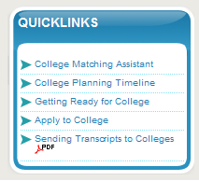
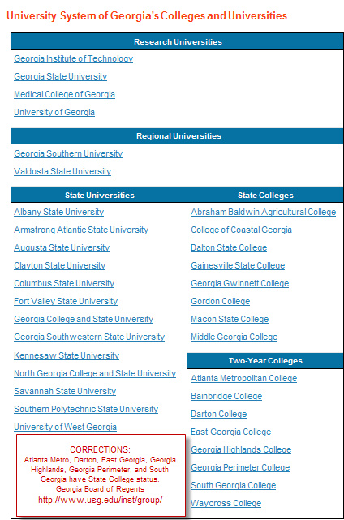

FIRST-TIME COLLEGE-BOUND STUDENT
SESSION # 6-College Application

Materials
- Lap-top and LCD projector or computer lab to “show and tell” the files on Gacollege411 regarding college admissions under the tab College Planning tab
- Download the brochure from the National Association for College Admissions Counseling, Student; Rights and Responsibilities as a handout at http://www.nacacnet.org/PublicationsResources/Marketplace/student/Pages/RightsandResponsibilities.aspx. There are other resources you may want to consider from this web site. If you cannot download the NACAC brochure, print the rights and responsibilities from Gacollege411 under the College Planning tab, to Prepare for College to Know the Steps to Rights and Responsibilities of College Applicants. A printed copy is located in the appendix.
- Gather practice applications from several colleges/universities in your area or around the state including a technical college application. Remind students that 411 has the capacity to “zip” applications to most Georgia schools.
- Give students the web site for the Common Application and explain that this application can be used at over 400 hundred schools. https://www.commonapp.org/CommonApp/default.aspx A list of institutions can be found on this web site. Most schools are private or independent schools such as Emory, Clark University, and Agnes Scott. A list of member colleges and universities is located at https://www.commonapp.org/CommonApp/Members.aspx
- Tip Sheet for writing the college application essay located in the appendix
Activities
- Activity # 1
  - College planning tools and materials located on 411. Create a brief overview of those materials and tools: Prepare for College to the College Timeline (suggest that the students print this timeline to assist them with planning and to include this handout in their folder or notebook) and the information available under the tab Getting Ready for College. Encourage students to utilize these tools and be sure to encourage them to share this web site information with their parents. NOTE: One of the most important issues is the parental involvement. If you have limited English speaking students, take every available opportunity to deliver information to students and parents in their native language. Many of the federal college-related sites have information in Spanish and English. The same is true with hearing and seeing impaired students. Consult with special needs personnel for assistance.
- Activity # 2
  - Handout the information on Rights and Responsibilities. Ask students to read this information keep this information in their folder/notebook. Tell them if they have questions to please see you in your office.
- Activity # 3
  - College Applications. Distribute the applications you have gathered. Ask the students to work in pairs as they fill out their application. Then ask them to find and list the things that were different in the two applications. Provide students with newsprint and a black marker to make their list. Once the students have completed the applications, have each dyad report their findings. Discuss with the students the most challenging parts of the application. Determine which applications did or did not require an essay: distribute the handout from the N.Y. Times. Remind the students that they can apply on-line through Gacollege411 under the College Planning tab. Encourage students to complete the practice application on-line before they do the “real” thing.
- Dismiss: SUGGESTED dismissal script, if you need assistance or need more information or need to utilize a computer, please see me. In the next session we will focus on financial aid and scholarships. I look forward to seeing you on ___________________ at _____________. Have a great day and if you need help, remember I am available. Also don’t forget to utilize Gacollege411 for additional information.
FIRST-TIME COLLEGE-BOUND STUDENT
SESSION # 7-Financial Aid
Materials
- Copy of the current FAFSA form
- Copy of the current CSS Profile form
- Download the ppt, “Financial Aid for Juniors” from Gacollege411 NOTE: This ppt does not include the current HOPE rules for 2011-2012
- Computer
- LCD projector
- List of other Financial Aid web sites
- Optional: FREE materials at Fastweb for Educators http://www.fastweb.com/content/educators?utm_source=toprightcallout
- Optional: FREE materials at Gacollege411 https://www.gsfc.org/gheac/order_loan/index.cfm?guid=&returnurl=https%3a%2f%2fsecure.gacollege411.org%2fHome%2fEducator.aspx
Activities
- Activity # 1
  - Financial Aid- Focus on the financial aid process including how to search for possible scholarships. The financial aid process can be complex; therefore the more information and tools you have the better. It will be especially important to share the information with their parents. There are two basic forms you will need:
    - # 1 is the Free Application of Federal Student Aid (FAFSA) This form will qualify students for some scholarships, state and federal student aid. They can begin the FAFSA process after January 1 of their senior year; but, they should become familiar with the form and process prior to that time. There are several sites they can access to complete the form. Distribute any free materials you may have gathered along with additional web sites. Tell students to keep this list of web sites in their folder so they and their family can refer to them when needed. “Show and tell” students the Gacollege411 web site under the Financial Aid Planning tab pointing out the tools and materials available.
      - 7 Easy Steps to the FAFSA-Explain to students that they should involve their family in this process. FAFSA information is provided in Spanish on the federal web site at www.fafsa.gov . Gacollege411 provides a tutorial that will assist you in completing the form. It runs fast so you may want to listen to it several times. The biggest tip is to contact your college financial aid administrator if you have specific questions. It is important that the students remember the more informed they have about the process the easier it will be when they begin to file for federal student aid. To qualify for HOPE Scholarship and Grant, they should complete the FAFSA. It is recommended that they complete the form on-line; however, there are other options such as paper and pencil.
- Activity # 2
  - Show the powerpoint located on Gacollege411 “Financial Aid for Juniors”. Tell students to gather information regarding the process and keep the information in their folder/notebook for future reference. NOTE: This ppt does not reflect the 2011-2012 new HOPE regulations but does offer a simple outline of resources and process.
  - 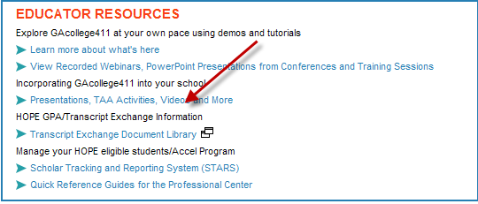
- Activity # 3
    - #2 the CSS Profile ($25.00 fee). This form is usually for private schools only and some scholarships and is used to help award nonfederal student aid funds. Note the scholarships and Georgia schools that require this particular form. You may want to print the Student Guide at https://profileonline.collegeboard.com/prf/VignetteServlet/VignetteServlet.srv?relativePath=/profile/pdfs/1112_profile_regist_guide.pdf to distribute. The National Merit Scholarship is the primary scholarship for Georgia students.
- Dismiss: SUGGESTED dismissal script: Next time we will discuss the HOPE program and other scholarships. Remember to use Gacollege411 as your primary tool for financial aid. See you on ____________________ at _______________. Have a great day.

FIRST-TIME COLLEGE-BOUND STUDENT
SESSION # 8- “Continue Financial Aid”
HOPE Program

Materials
- HOPE brochures and flyers from Gacollege411 under the tab “Communications” at the bottom of the home page OR print the following page for review https://secure.gacollege411.org/Financial_Aid_Planning/HOPE_Program/_default.aspx
- Print the handout for additional web sites
- Print the handout from FastWeb regarding the scholarship search
- Handouts-2011-2012 HOPE rules and regulations located in the appendix
- Activity # 1-
  - Explain the HOPE Scholarship Program has changed for students attending Georgia colleges. It no longer pays 100% of tuition or books and fees at GA public colleges for students earning a 3.0 core GPA.
  - Explain the following basic vocabulary: (Consider writing these terms on a flip chart or board)
    - Postsecondary education is any education you receive beyond high school. Examples include technical colleges and 2-year and 4-year colleges;
    - Certificates and diplomas are non-degree offerings below the associate degree and are most often offered in technical programs of study. They generally lead to employment in an occupational field. Examples -Certificate in Office Admin. Bookkeeping, Certificate in Automotive Technology, Diploma in Cosmetology;
    - Associate Degree is generally 2 years of college study and may be sufficient for entrance into an occupational field or may be used for transfer to a 4-year college or university;
    - Bachelor Degree, sometimes called a baccalaureate degree, generally requires 4 to 5 years of study and requires courses in a major and electives.
    - Core GPA is the average of attempted courses in English, math, social studies, science, and foreign language. It is NOT your cumulative GPA.
- Activity # 2-
  - (Distribute Handout 1—HOPE Summary Guidelines)- Present this information regarding the changes- what has not changed regarding the HOPE Scholarship. (Read/discuss the first paragraph of Handout 1 then read/discuss the rest of Handout 1.) Allow time for questions students might have regarding the changes.
- Activity # 3:
  - (Distribute Handout 2)—Discuss utilizing the chart to show students how they can calculate both HOPE Scholarship funds and Zell Miller Scholarships. Let the students provide scenarios to determine the HOPE award. ie The HOPE award for students attending the University of Georgia taking 15 hours; the Zell Miller award for attending Macon State College; a private college/university; technical college taking 12 hours. Remind students that what you do in high school has a direct impact on what you do after high school AND how much money you have to do it with.
- Tell students to utilize Gacollege411 and other web sites to research the possibilities of other scholarship opportunities under the Financial Aid tab. Make reference to the FastWeb handout. Also they may want to print the financial aid timeline to help them stay on track. Tell students, if they need additional assistance to please let you know.
- Dismiss with SUGGESTED script: I hope you have learned more about the financial aid process and that you are not as concerned about the process as you were prior to these sessions. Remember I am always available to help you should you need it. See you the next time we meet on ____________________________________.

FIRST-TIME COLLEGE-BOUND STUDENT
SESSION # 9-Dual Enrollment
“College Credit Now”

Materials
- Dual enrollment handout as a review
Activity # 1
- Handout the Dual enrollment handout located in the appendix. Ask if any students are currently enrolled in any one of these programs. If so, let the student(s) discuss their experiences. If not, explain that these programs allow students the opportunity to earn both high school and college credit at the same time. The primary benefits are: saves money and time. Remind them that they should have already been introduced to the dual enrollment programs earlier. Ask if they have any questions and encourage them to take advantage of or at least consider taking courses that could count at both the secondary and postsecondary school. Remind students that Gacollege411 has information regarding the dual enrollment opportunities in the COLLEGE CREDIT NOW box located under the High School Planning tab.
Activity # 2 is to prepare for the last/final group session:
- Divide the students into 2 or 3 equal groups. Allow them to discuss and list questions they would like to ask about “going to college”. Tell students they will have their opportunity to ask questions the next sessions. A panel of college admissions representatives will be available: one from a large institution, one from a smaller institution and one from a technical college. Give student about 10-15 minutes to discuss then handout the list of questions located in appendix for reference. Allow them the rest of the time to make their list of questions. Maintain a copy of the questions to share with the representatives prior to their coming.
Suggested script for Dismissal-I am looking forward to the next session. I hope you are. If think of other questions between now and then, please write them down so you can get your answers. Have a great week and I will be available if you should need me. Please let me make a copy of your questions before you leave.
FIRST-TIME COLLEGE-BOUND STUDENT
SESSION # 10 Postsecondary Panel/Evaluation

Materials
- Post evaluation
- A panel of postsecondary representatives from surrounding colleges/universities (1 four-year public college/university; 1 two-year public college; 1 technical college) to answer questions regarding college life (living away from home), financial aid, and admissions criteria.
Activities
- Activity # 1 Provide space to set chairs in a semi-circle for students and chairs located at the opening of the circle for the panel. Please provide name tags for students and representatives with names written large enough for all participants to read. Students should have created a list of questions prior to the activity as an assignment from the last session. These questions should have been shared with representatives prior to attending.
- Activity # 2 Allow each representative to introduce themselves. Allow the students to introduce themselves by name and grade level. Allow students to ask questions for about 40 minutes. Optional: To provide some simple refreshments.
- Activity # 3 Distribute the post-evaluation. Allow students time to complete the evaluation.
- Suggested dismissal: Thank students for participating and tell them that you are available for any question or assistance they may need in the future.

Please write thank you notes to those postsecondary representatives that participated. Consider allowing the students write the thank you notes.


First-Generation
College Students

Small group sessions:
Who: 10th or 11th grade students
Dates:
Where:
Time:
Have your parents ever attended college? If not you may want to consider attending these group sessions. Do you want to go to college but don’t know all the ins and outs to get there? In the space below, briefly record why you would like to be a part of these small sessions.

Name_____________________________________________HR________________

Please return this flyer with parental signature by __________. Please see additional information on the reverse of this sheet to participate.

Dear Parent/Guardian:

The Professional School Counseling Program will offer small group sessions to focus on students who will be attending college as a first-generation college student. These are students who have parents that never enrolled in college. Research indicates that these students need additional support and encouragement to make good decisions about career and educational choices. We have found that working with students in small groups is a supportive and engaging strategy to assist them. We would like to provide 10 small-group sessions (8-10 students in each group) during the school day. Meeting times will rotate so that students do not miss the same class every time. During these 10 sessions we will:
- Review the career planning process
- Review graduation requirements
- Review student transcripts
- Learn about college admissions requirements to Georgia public colleges/universities
- Learn about the application process
- Learn about other possible options to continuing education
- Learn about financial aid resources
- Become familiar with the transitioning process to college life: housing, study-skills and other on-campus issues from a representative panel of college freshmen
We are delighted your child has expressed an interest in these group meetings. We will need your permission for your child to participate.

Signature:_____________________________________________________

Comments (optional):_____________________________________________________

FIRST-TIME COLLEGE-BOUND STUDENT
PRE AND POST EVALUATION
Activity # 1 and #10

Please answer the follow questions by circling your most appropriate answer:
1 | I am concerned about my transition from high school.
 | Strongly agree | Agree | Uncertain | Disagree | Strongly Disagree
2 | I need more information about which educational option is the most relevant to my future career.
 | Strongly agree | Agree | Uncertain | Disagree | Strongly Disagree
3 | I am anxious about moving away from home to live on a college campus.
 | Strongly agree | Agree | Uncertain | Disagree | Strongly Disagree
4 | I am uncertain about my future career choice.
 | Strongly agree | Agree | Uncertain | Disagree | Strongly Disagree
5 | I need more information about the college admissions process.
 | Strongly agree | Agree | Uncertain | Disagree | Strongly Disagree
6 | I am anxious about being prepared for college-level course work.
 | Strongly agree | Agree | Uncertain | Disagree | Strongly Disagree
7 | I need more information about the financial aid process.
 | Strongly agree | Agree | Uncertain | Disagree | Strongly Disagree

Answer the following questions after the last session only:
After you complete the POST-evaluation above, please take few minutes to express your experience in this group. What did you find most helpful? What recommendations would you make to enhance this small group process better? Did you enjoy the experience? Would you recommend this group to other students?

Example of Wreath/Session # 1
Tape the hands from the back side together to form a wreath after students have reached a consensus on their top five issues or concerns regarding going to college. (Optional: If you feel this has value, maintain this wreath to reinforce the purpose of the group sessions.)


Admissions Requirements
Financial Aid
Session #2

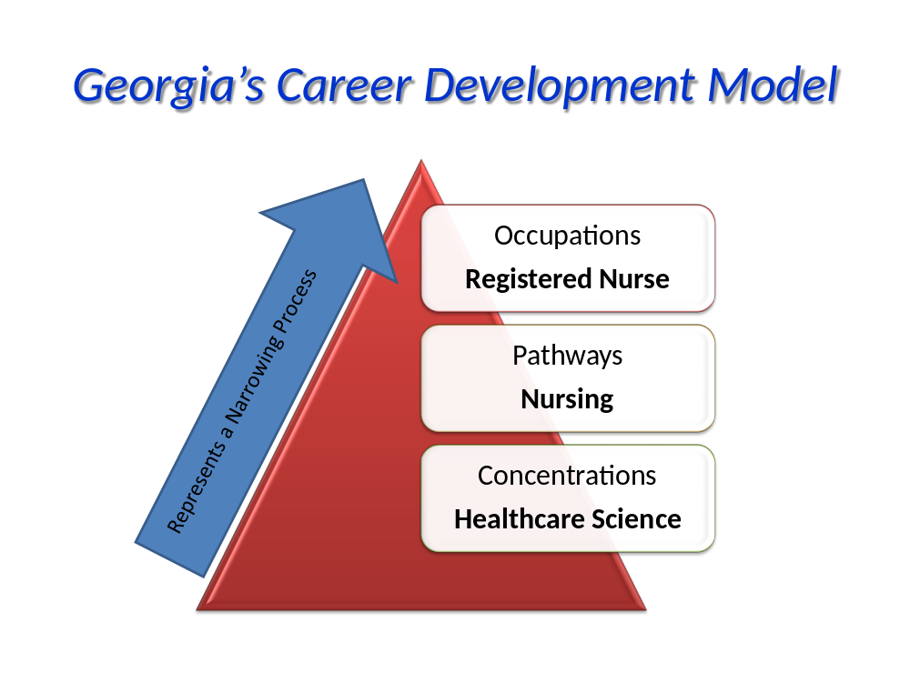
Session # 3
*Student Credit Checklist Class of _____________
Name________________________ Selected Career Pathway _________________
Instructions: Place a checkmark in each circle for each credit you have passed. Circle courses that you failed and will need to repeat in order to graduate with your class.
English-4 credits  - English 9  - English 10  - English 11  - English 12 | Math-4 credits  - Math I/ /GPS Algebra/or Equivalent Math  - Math II/ GPS Geometry / or Equivalent Math  - Math III/ /GPS Advanced Algebra/ or Equivalent Math  - Math IV/GPS Pre-Calculus/ or Equivalent Math
Social Studies- 3 credits  - Economics (.5 credit)  - Political Science (.5 credit)  - World History  - U.S. History | Science-4 credits  - Physical Science or Physics  - Biology  - Chemistry  - 4th Science
Physical Education & Health-1 credit  - Physical Education (.5 credit)  - Health (.5 credit) | Fine Arts and/or Foreign Language and/or Career, Technical and Agriculture Education (CTAE)-3 credits (record your courses)  Career Pathway courses  Fine Arts  *Foreign Language  *Students attending 4-year Georgia public college/university will be required to earn two credits in the same foreign language.
Selected Electives-4 credits (record your courses)

Students must earn 23 credits in specific courses to meet graduation requirements.
Georgia University System schools require 2 years of foreign language for admissions.
How many credits have you earned?______________________
How many more credits do you need? ____________________
Do you need to make up any courses? YES NO If yes, how do you plan to make up those classes?
__________________________________________________________________________________________________________________________________________________________________________
*This checklist represents the current state graduation requirements for 9th graders enrolling in2008-2009.
Remember GAcollege411 can compare your credits with graduation requirements.

Session 3
Current Georgia Graduation Rule for students enrolling in the 9th grade in the fall of 2008-2009:

Areas of Study: | Credits
- English/Language Arts | 4
- Math | 4
- *Science | 4
- Social Studies | 3
- **Career, Technical and Agricultural Education (CTAE),  and/or Modern Language/Latin, and/or Fine Arts | 3
- Health & Physical Education | 1
- Electives (4 units) | 4
TOTAL UNITS | 23
* Some 4th Science courses may be used to meet both the required science and required elective in CTAE sequence of courses (V)
**Student must complete 3 units in a pathway to complete CTAE pathway and take end of pathway assessment; Student must complete 2 years of the same foreign language for admissions to Georgia Board of Regents colleges/universities.

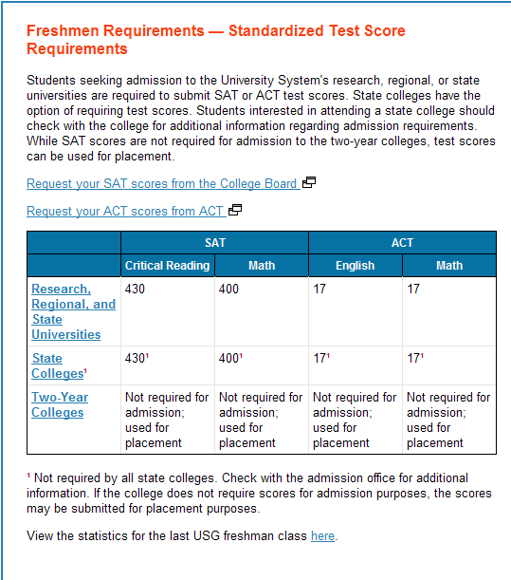
Session # 3

Session # 3
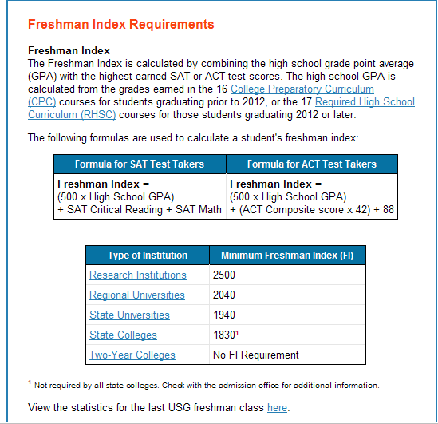
Session # 5
FIRST-TIME COLLEGE-BOUND STUDENT
FRESHMAN INDEX & ADMISSIONS TESTING QUESTIONS

1. Georgia Board of Regents divided public colleges and universities into different categories: What are these levels?

Note: For your information four colleges have been moved from the two-year colleges to the state colleges: Atlanta Metropolitan College; Darton College; Georgia Highlands College; Georgia Perimeter College

2. What impact do these categories have on admissions to selected public colleges/universities?

3. How is the Freshmen Index calculated?

4. How are the Two-Year Colleges different when considering the Freshman Index?

5. Do all State Colleges require the Freshman Index?

6. Figure your Freshman Index score if your High School GPA is 2.8, your SAT Critical Reading Score is 450, your SAT Math is 480.

7. Figure your Freshman Index score if your High School GPA is 3.0, your ACT composite score is 21.

8. Where can you find the Freshman Index scores for the different categories?

9. If you are interested in looking at the University System of Georgia freshman class statistics, where can you find them?

10. Where can you find the admissions testing information?

11. How can you request your scores for SAT and ACT?
Session # 5 Continued

12. Are there different scores for the different categories? What are the scores at each category?

13. Do all state colleges require an SAT or ACT score? What should I do to find out?

14. Which admissions test should I take, SAT or ACT?

15. Do two-year schools require the SAT or ACT? What is meant by placement only?

16. How can I register to take the SAT or ACT?


Remember you can gather information from Gacollege411 (www.gacollege411.org) under the College Planning tab in the following files:
- Prepare for College-Admissions requirements
- Test Prep-SAT, ACT and Compass Prep
- Explore Postsecondary Schools-utilize the college matching tool to assist with finding the right college
- Explore Programs and Majors-Explore possible programs and majors that match your career choice
- Applications and Transcripts-send applications and transcripts electronically

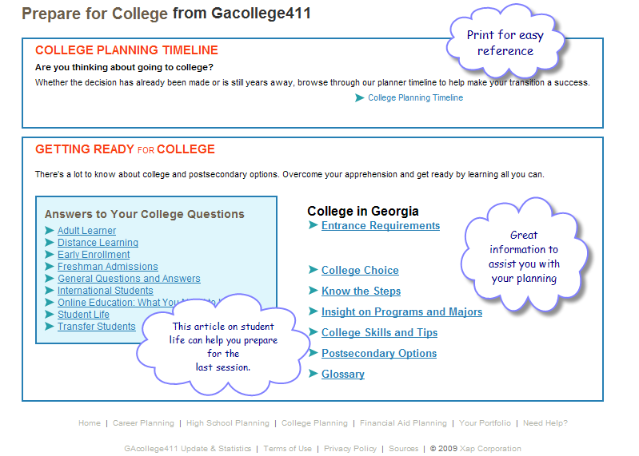
Session # 6
Prepare for College from Gacollege411: Become familiar with this information, to assist you with the transition from high school to postsecondary schools.

Session # 6

The College Essay:

The Choice: Demystifying College Admissions and Aid (http://thechoice.blogs.nytimes.com/ ); for other Times Topics go to http://topics.nytimes.com/top/reference/timestopics/subjects/c/colleges_and_universities/admissions/index.html )
June 23, 2009, 12:22 pm

Tip Sheet: An Admissions Dean Offers Advice on Writing a College Essay
By MARTHA C. MERRILL
Periodically, in a feature called “Tip Sheet,” The Choice will post short items by admissions officers, guidance counselors and others to help applicants and their families better understand aspects of the admissions process. As an inaugural post in this series, Martha C. Merrill, the dean of admission and financial aid of Connecticut College, and a graduate of the class of 1984, encourages incoming high school seniors to begin contemplating their college essays this summer. She also offers perspective on what she looks for in an applicant’s essay.
Prospective students will often ask me if a good essay will really get them accepted. The truth is that while no essay will make an unqualified student acceptable, a good essay can help a qualified applicant stand out from the competition. A good essay just might be what turns a “maybe” into a “yes.”
The college application process takes time, preparation and creativity, which is a lot for any active senior to handle. Summer, however, typically offers about 10 weeks free of classes and homework and many of the other stresses that come with high school. The pressure of the looming college application deadline is still months away, which allows students the freedom to play around with different ideas, test different angles and solicit feedback from friends and family.
Another reason to focus your summer energy on crafting a quality essay: at this point in the admission process, it is one of the few things you can still control. This is your chance to show us what you are capable of when you have time to think, prepare, rewrite and polish.
While there is no magic formula for the perfect admission essay, there are a few things prospective college students should know. Here are my Top Ten tips:
Write about yourself. A great history paper on the Civil War might be very well written, but it doesn’t tell me anything about the writer. Regardless of the topic, make sure you shine through your essay.
Use your own voice. I can tell the difference between the voice of a 40-year-old and a high school senior.
Focus on one aspect of yourself. If you try to cover too many topics in your essay, you’ll end up with a resume of activities and attributes that doesn’t tell me as much about you as an in-depth look at one project or passion.
Be genuine. Don’t try to impress me, because I’ve heard it all. Just tell me what is important to you.
Consider a mundane topic. Sometimes it’s the simple things in life that make the best essays. Some of my favorites have included essays that reflect on the daily subway ride to school, or what the family goldfish observed from the fishbowl perched on the family kitchen table. It doesn’t have to be a life-changing event to be interesting and informative.
Don’t rely on “how to” books. Use them to get your creative juices flowing, but don’t adhere too rigidly to their formulas, and definitely don’t use their example topics. While there are always exceptions, the “what my room says about me” essay is way overdone.
Share your opinions, but avoid anything too risky or controversial. Your essay will be read by a diverse group of individuals from a wide range of backgrounds, so try to appeal to the broadest audience possible.
Tell a good story. Show me why you are compassionate; don’t tell me you are. Show me that you have overcome great difficulty; don’t start your essay with “I have overcome great difficulties.”
Don’t repeat what is already in your application. If you go to a performing arts school and all of your extracurricular activities and awards relate to dance, don’t write about how much you love dancing. Tell me something I couldn’t know just from reading the other parts of your application.
Finally, don’t forget about the supplements. The supplement questions are very important – you should plan to spend as much time on them as you do on your essay. A well-written essay won’t help if your supplement answers are sloppy and uninformative.
Copyright 2011 The New York Times Company Privacy Policy NYTimes.com 620 Eighth Avenue New York, NY 10018
Session # 6


Rights and Responsibilities of College Applicants from Gacollege411

Rights
As a college applicant, you have the right to receive information from colleges and universities about their admission, financial costs, financial aid opportunities and housing policies. "When you're accepted into a college, and you decide to go there, you're entering into a contractual agreement," says Deloris Richardson. "So you need to know where you stand, and what's expected." Richardson is assistant director for education and training at the National Association for College Admission Counseling (NACAC). "It's kind of like a bill of rights," she says. "You have to know what you're entitled to so you don't fall prey to some predatory type of school... a fly-by-night institution that has students paying exorbitant fees. You have a right to protect yourself and know." The U.S. government requires colleges and universities to provide the following information to prospective students, according to NACAC:
- Costs, including tuition, books, supplies, housing and other fees
- Requirements and procedures for withdrawing from the school, and refund policies
- Academic programs, a list of faculty members and instructors, graduation or completion rates, transfer-out rates (for schools that prepare students for transfers to four-year colleges)
- Types of financial aid available, criteria for determining eligibility, how and when aid is distributed
- Names of associations that accredit, approve or license the school
- Services and facilities for students with disabilities
- The number and types of crimes reported on or near campus, policies and procedures for reporting campus crimes and emergencies, and the college's policy on drug offenses
Freedom from high-pressure sales is another right of prospective students. Even if you're applying early, you have the right to complete information about the college's admission process and policies. Most colleges make this information available on their websites, in college catalogs, or in other materials. "The information is usually in print right before [students]," says Richardson. "It's on the travel brochures. It's in the prospectus. They will also receive mailings to their homes letting them know what costs are.... And so it's really up to them to actually read it, and then go from there."

Colleges and universities also have policies and procedures for enrolled students around student conduct, discipline, discrimination, harassment, student grievances, and alcohol and drug use, which may differ from school to school. This information is typically found on the schools' websites or in college catalogs.

Responsibilities
As a student applying to college, you have certain responsibilities too. You must research, understand and comply with the college's policies and procedures around application fees, financial aid, scholarships, housing and deposits. It's important to understand the college's on-campus policies and procedures, such as student conduct, because you'll be expected to observe those policies once you're a student at the school.

When applying to a college, it's your responsibility to complete all required material and submit your application on or before the deadline. Be sure to fill out your applications yourself. When you receive an offer, you must inform each college or university whether you're accepting or rejecting the offer -- no later than May 1. (Early decision programs are an exception to this deadline.)

Information about what you need to do as a college applicant is typically available on college websites, in e-mails and snail mail sent to applicants, and on the application form itself.
"I would like to think we do a pretty good job of telling [students] you have to do this, this, this and this, and we'll take it from there," says Chris Portney. She works in the admissions department at the University of Arizona. "The best thing is to check e-mails -- which [students] often don't -- and follow through."
College applicants' rights and responsibilities are made available to protect colleges as well, says Portney. "We're not doing our job if we're holding something back," she says. "And miscommunication can lead to a lot of problems for both sides." Overall, Portney finds that student applicants are generally aware of their rights and responsibilities. "From an admissions standpoint ... this millennial generation is very different from previous ones," she says.
"They are much more informed. Everything they click, click, click on the web, and they can find it if they are motivated, and the majority of them are. And Mom and Dad are much more involved.... They're better informed than they used to be, and the follow through is better."

If you feel your rights have been denied, contact the college or university for more information. Speak to your high school guidance counselor or a college advisor. Or contact NACAC for assistance.
Students may contact the college if they're denied acceptance, says Marie Alford, director of admissions at California State University, Long Beach. "Many times we have students who are fairly good students, who we can't admit simply because we get so many more applicants than we can accommodate," she says.
"And I will just help them understand that while they did a good job, and they certainly have academic potential, at our campus we can only admit so many students, and unfortunately that cutoff just has to be drawn somewhere."
In most cases, issues are resolved after speaking with an admissions officer, says Alford. However, in some cases, students appeal their admission decision if they believe the college did not have their most recent test scores or GPA. "When we get those, we just verify our records and make sure we do have the correct information," says Alford. "If we've made an error, we certainly will reverse it." Alford advises students to start preparing for college during their junior year of high school. "[Students should] identify where they want to go to school," she says. "And they have to consider more than one -- preferably three or four. And then get on the website, look at the requirements for each one of those schools ... and talk to the counselor. "Call the universities and ask questions," she adds. "Admissions offices and outreach offices are always there to answer students' questions."
Session # 7


HOPE Summary Guidelines 2011-2012
Handout 1
HOPE Scholarship (for students seeking a degree):
Basic Eligibility Requirements for HOPE Scholarship that have NOT changed:

- Be a citizen—A student must be a United States citizen or an eligible non-citizen for 12 consecutive months immediately prior to the first day of classes of the school term for which HOPE is sought;
- Be a resident—A student must be a Georgia resident for 12 consecutive months immediately prior to the first day of classes of the school term for which HOPE is sought;
- Register with the Selective Service (if applicable)—A student must be in compliance with United States Selective Service System requirements prior to the HOPE application;
- Be in compliance with the Georgia Drug-Free Postsecondary Education Act of 1990;
- Attend an eligible Georgia school;
- Graduate from an eligible high school with a 3.0 GPA in core courses as calculated by the Georgia Student Finance commission (GSFC);
- Maintain a 3.0 GPA while in college.

Changes in the HOPE Scholarship:
- The HOPE Scholarship will pay:
  - At an eligible public postsecondary institution, for FY2012, a percentage amount of the standard tuition charges from the previous year. View award amounts at http://www.gsfc.org/main/publishing/pdf/2011/hope_award_amounts.pdf. Every year these amounts will change based upon lottery revenues, HOPE enrollment numbers, and the previous year’s award rate;
  - At an eligible private postsecondary institution, a percentage amount of the HOPE award for private colleges (for FY 2012 the maximum amount is $3,600/year for 15 hours);
  - A separate Tuition Equalization Grant (TEG) in the amount of $700 for FY 2012 is also available for students attending eligible private colleges in Georgia;
  - No book or fee allowances;
- The HOPE Scholarship will NOT pay for remedial or developmental courses;
- If a student falls below a 3.0 GPA while in college, he/she may regain the HOPE Scholarship only one time;
- Beginning with the Class of 2015 (students entering high school in 2011-2012), a new rigor requirement has been added. Students graduating in 2015 must pass at least 2 courses from a list of academically rigorous courses to meet requirements to be a HOPE Scholar upon high school graduation (i.e., courses in advanced math, advanced science, advanced foreign language, AP or IB courses in core subjects, and/or dual enrollment courses taken at a unit of the University System of Georgia in core subjects, not remedial or developmental). GSFC will provide a list of classes to further define each category.

Page 2
Zell Miller Scholar Program—a New Program (for students seeking a degree):

- Students who become a Zell Miller Scholar must meet all requirements for the HOPE Scholarship, PLUS. . .
- Graduate from an eligible high school with a 3.7 or greater GPA in core subjects as calculated by GSFC AND receive a score of at least 1200 combined critical reading and math score on a single administration of the SAT, or an ACT composite score of 26, or. . . .
- Graduate from an eligible high school as the valedictorian or salutatorian;
- Maintain at least a 3.3 GPA in college to remain eligible for the Zell Miller Scholar program;
- The Zell Miller Scholar payment guidelines are the following. . . .
  - For Georgia public universities/colleges or Georgia Technical colleges, Zell Miller Scholars will have their tuition fully paid during the then current year, without regard for specific program of study;
  - For Georgia private colleges, Zell Miller Scholars will receive $4,000/yr for 15 hours for FY 2012;
  - On-line chart for Zell Miller Scholar award amounts for Georgia public institutions is the second page of the following link: http://www.gsfc.org/main/publishing/pdf/2011/hope_award_amounts.pdf

HOPE Grant (for students seeking a certificate or diploma):

- Only available to students seeking a certificate or diploma at a branch of the Technical College System of Georgia (TCSG) or a unit of the University System of Georgia;
- While there is no GPA requirement for the HOPE Grant upon entering a program at a TCSG school in Fall 2011, all HOPE Grant recipients must have a 3.0 GPA on all HOPE Grant coursework, excluding dual enrollment and learning support courses, when GPAs are checked at the completion of 30 and 60 hours;
- Students losing eligibility at the 30 hour checkpoint may regain eligibility at the 60 hour checkpoint if the student achieves a 3.0 GPA at that point;
- HOPE Grant will pay. . . .
  - A percentage amount of the standard tuition charges from the previous year;
  - Students can use the chart posted on GAcollege411 to determine exact amounts for 2012 (http://www.gsfc.org/main/publishing/pdf/2011/hope_award_amounts.pdf).

☺☺☺☺☺☺☺☺☺☺☺☺☺☺☺☺☺☺☺☺☺☺☺

Also, go to www.gacollege411.org
“What’s New”
HOPE Program Changes

Georgia Department of Education/Career, Technical and Agricultural Education would like to thank Forsyth County Professional School Counselor, Dr. Sharon McWhorter, for sharing this document. Please give Forsyth County Professional School Counselors credit for their work if this document is duplicated.
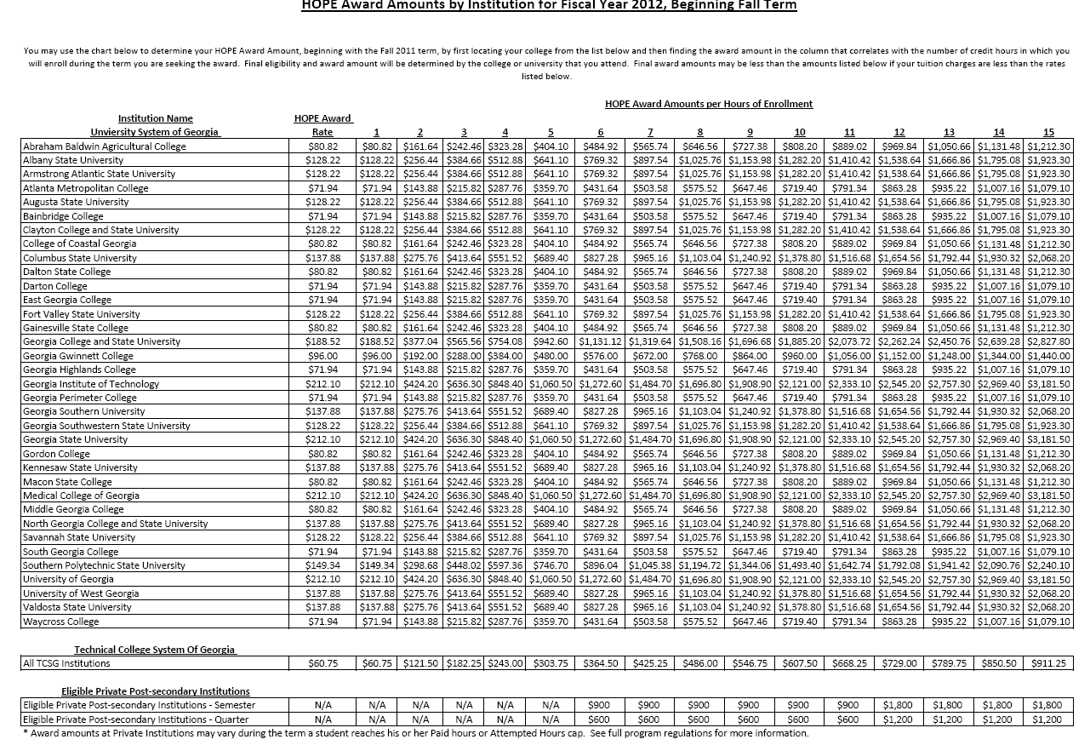
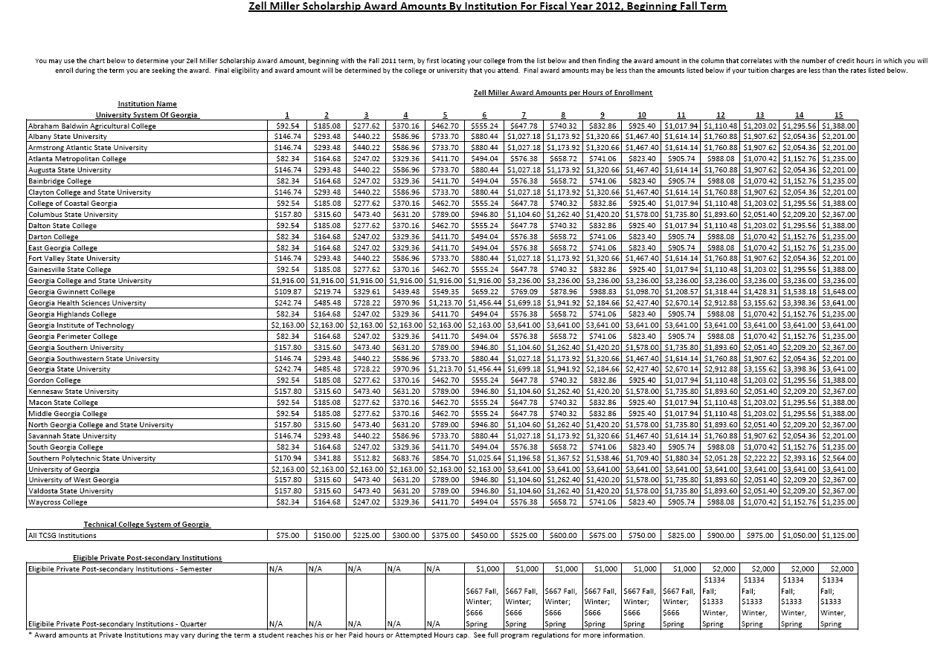
Session # 7

Financial Aid web sites one might consider:
Welcome to Student Aid on the Web
http://studentaid.ed.gov/PORTALSWebApp/students/english/index.jsp A government web site that offers information on preparing for and funding education beyond high school. The menu includes: How to Use Our Site, Federal Student Aid Programs, MyFSA, Applying for College and Applying for Financial Aid, Repaying Your Loans, Tools and Resources, and a Glossary. This information is provided in English and Espanol. Check the current top eighteen most frequently asked questions at https://studentaid.ed.gov/PORTALSWebApp/students/english/faqs.jsp?backURL=/xap_pack/Default.asp&Language=en&returnurl=/students/english/faqs.jsp

FinAid http://www.finaid.org/

Get help paying for college at http://www.fafsa.ed.gov/#

fastweb http://www.fastweb.com/ A FREE scholarship search. See fastwebs 2-page document on “Winning a Scholarship Quick Reference Guide” at http://www.finaid.org/scholarships/WinningaScholarship.pdf
College Board: College Board's free online Scholarship Search at http://apps.collegeboard.com/cbsearch_ss/welcome.jsp . Other free searches are available at http://www.srnexpress.com/, and http://www.collegeanswer.com/

Other web sites one might consider:

KnowHow2Go http://www.knowhow2go.org/ Contains a section on financial aid and contain other valuable information regarding the college experience.

Going2 College http://going2college.org/StateResources/ Contains a section on financial aid and contain other valuable information regarding the college experience.
Yes I Can: www.YesICan.gov OR www.yosipuedo.gov – A federal government web site designed for Hispanic students.
Most all of these web sites above also contain a scholarship section. Take the time to explore the possibilities.

Session # 8

12 Tips on Winning a Scholarship

January 21, 2011
What if you had all the secrets to winning a scholarship? Would you tell the world — or keep them for yourself? Fastweb’s publisher, Mark Kantrowitz, does have all the secrets, and fortunately, he’s spilling everything he knows.
Kantrowitz has provided Fastweb with the top 12 tips on winning a scholarship:
1. Start searching for scholarships as soon as possible. Don’t wait until spring of your senior year in high school to start searching, or you’ll miss half the deadlines. There are many scholarships available to students in grades 9, 10 and 11, not just high school seniors. There are even scholarships for students in grades K-8. Continue searching for scholarships even after you are enrolled in college.
2. Answer all of the optional questions on a scholarship matching web site for about twice as many matches.
3. Use a free scholarship matching service like Fastweb.com. The Fastweb database is updated daily, and the site will email you notifications of new scholarships that match your personal background profile.
4. Look for local scholarships on bulletin boards near the guidance counselor of financial aid offices, or the library’s jobs and careers section.
5. Apply to every scholarship for which you are eligible. Pursue less competitive scholarships, such as small awards and essay contests, since they are easier to win and the money adds up and helps you win bigger scholarships.
6. Don’t miss deadlines. Use a calendar and checklist to get organized.
7. Tailor your application to the sponsor’s goals. Read and follow the instructions carefully.
8. If you have difficulty writing essays, try recording yourself as you answer the question out loud, and transcribe the recording later. Most people can think and speak faster than they can write or type. Create an outline afterward to organize your thoughts.
9. Personalize your essay and be passionate. Write about something of interest to you. Make your application stand out from the crowd. Talk about your impact on other people. Give examples and be specific.
10. Google your name and make sure you have a professional online profile. Use a professional email address, such as firstname.lastname@gmail.com. Clean up the content of your Facebook account, removing inappropriate and immature material.
11. Proofread a printed copy of your essay and the application for spelling and grammar errors.
12. Make a photocopy of your application before mailing it. Send the application by certified mail, return receipt requested or with delivery confirmation.

Session # 9
DUAL ENROLLMENT/2011-2012
“College Credit Now”

Defined as programs that provide opportunities for Georgia high school students to take college-level courses and earn concurrent credit toward a high school diploma and a college degree while still in high school.
- ACCEL is a non-need based grant program offered for students that wish to take college-level (academic-only, degree-level) coursework for credit toward both high school and college graduation requirements. https://www.gsfc.org/gsfcnew/SandG_regs_2010.cfm (does not count against the HOPE paid hours beginning fall 2011
- HOPE GRANT is a non-need based grant program for students seeking technical certificates or diplomas from TCSG postsecondary institutions. (does not count against the HOPE paid hours) http://www.gsfc.org/main/publishing/pdf/2010/regulations/hope_grant.pdf
- Move On When Ready (MOWR) provides an eligible 11th or 12th grade student to take ALL of his or her courses through an eligible institution and/or a virtual program. Students receive secondary and college credit for completing graduation and high school diploma requirements. http://www.gadoe.org/ci_cta.aspx?PageReq=CICTASeam (does not count against the HOPE paid hours)
- Early College is a partnership between a designated local school system and University System of Georgia institution. There are twelve Early Colleges in Georgia. Students can earn a high school diploma as well as coursework toward an Associate’s or Bachelor’s degree. http://www.gaearlycollege.org/
- Gateway To College is located exclusively on a college campus and is site specific through local agreements between local school systems and colleges. Currently the program is located at Georgia Perimeter College & Savannah Technical College. http://www.gatewaytocollege.org/partner_programs.asp

- Residential Programs are offered for gifted, talented, and motivated students through the University System of Georgia at two institutions:
  - The Advanced Academy of Georgia on the campus of the University of West Georgia http://www.advancedacademy.org/
  - The Georgia Academy of Mathematics, Engineering and Science at Middle Georgia College http://www.mgc.edu/Academics/Natural-Science-Math/GAMES/

- Articulated Credit is a partnership/agreement between the local high school and the local postsecondary institution whereby students are awarded postsecondary credit for high school courses that have been determined equivalent to the college-level course.



REMEMBER:

- Beginning Fall 2011 all Accel hours will not count against the HOPE cap. All hours before Fall 2011 will still count against the Accel cap.
- Local systems will receive FTE funding for College Credit Now students, except for MOWR participants, beginning Fall 2011.
Session # 9
Possible Questions for panel of college representatives:
When are tours offered? Who gives the tour? Do you have an open house?
What percentage of your students graduate in four years?
Are there advisors for each student? How much time are they required to spend with each student?
What is the average class size? What is the largest?
What extracurricular opportunities are available on campus?
Where is the health center?
How far is the health center from the dormitories?
What are the operating hours of the health center?
Is a doctor always on call?
Who staffs the center and what are their credentials?
Do you offer counseling programs or support groups?
How can I make an appointment?
What are the health requirements?
What forms do I need to fill out?
What are the costs?
Does the college offer health insurance coverage?
Will our family's current health insurance be accepted at local hospitals and the college health center?
Does the health center refer to a nearby hospital? Which one?
Which hospital will I be taken to in an emergency?
Will the campus transport me when I’m sick, or will I have to walk?
Do campus shuttle buses run at frequent intervals all night?
Does the school provide student escorts to accompany students walking on campus or to off-campus housing late at night?
Are "blue-light" telephones liberally placed throughout the campus for you to use to call for help?
Who provides campus security? (Contracted or on-site?)
Does campus security patrol campus regularly?
How much crime is there both on and adjacent to campus?
Does the dormitory have a sprinkler system and fire extinguishers?
Is the college in a suburban, urban, or rural area?
Is there an actual ‘campus’ or are buildings spread out in different areas of town?
Do the nearby businesses employ college students?
Does there seem to be a positive ‘town-gown’ (townspeople and college students) relationship?
Are there pharmacies, grocery stores, bookstores and laundromats nearby?
Are there interesting restaurants?
What kind of entertainment options are nearby?
Is the center of activity easy to walk to or do I need a car?
Is there public transportation to and from the campus throughout the area?
When do freshman move in?
When does upper classmen move in?
What is the ratio between classes (number of freshmen, sophomores, juniors, seniors)
Do most students live on campus or commute?
Do you require that students live on campus for a certain time period? (Some require students to live on campus for the first year or two.)
Will I be guaranteed on-campus housing?
Do the dorms close over breaks? Do I have to move out?
Are roommates assigned or can I choose my roommate?
How do you assign roommates?
If I have a problem with my roommate, who can I talk to about the problem?
Can I change roommates in the middle of the semester?
Are there freshman and upperclassmen dorms?
Are the dorms co-ed or single-sex?
Are bathrooms coed?
Are there substance-free dorms?
Are there quiet study areas?
Is there a student lounge?
What are the visitation policies in dorms?
Is there a quiet time enforced every night for studying?
Are laundry facilities available?
Are there computer and phone hookups in all the rooms?
Will I need to bring my own computer?
If I don't own a computer, are there computer labs available?
Do you have 24-hour labs? Are they located in or near student housing?
Are there computer support services on campus?
Do you have storage available for breaks or over the summer?
Where is the storage and how much am I allowed to store?
What about study-abroad storage?
Where is the dining hall?
Is it near student housing?
What are the hours of service?
What meal plan options are available?
How do I pay for the meal plan?
Will you be able to accommodate my dietary preferences (i.e. veganism, diabetes, lactose or gluten intolerance, etc.)?
Can first-year students have cars on campus? What is the fee for a parking permit?
Do I need to get a new driver’s license if I’m from out-of-state?
Do you offer any airport or other regular shuttles?
Approximately how much spending money will I need? Each week? Each month?
Is there a campus spending account card for things like laundry, school supplies, books, printing and copying, etc.?
Where do I open a bank account?
Where do I collect mail? How do my parents, family and friends send packages?
What student groups are on campus?
Are students on campus politically active?
In general, is the campus more liberal or more conservative?
Are there sororities and fraternities? Do they play a large part in the school’s social life?
What are your most popular social events on campus?
How can I find out about events on campus?
What kind of intramural sports are available?
What kind of competitive sports are available?
Has the school won any recent competitions or division titles?
Are there athletic scholarships available?
Is there a student gym facility?
Are there physical education classes I can take along with my other core curriculum classes?
Getting Ready for College Glossary from Gacollege411

AA Degree: Associate of Arts degree. (See Associate's Degree, below)
AAS Degree: Associate of Applied Science degree. (See Associate's Degree, below)
AS Degree: Associate of Science degree. (See Associate's Degree, below)
ACT: This is the college entrance exam required by more four-year colleges than any other exam. It measures high school students' educational development and ability to do college-level work. The multiple test section includes English, math, reading and science. There is also an optional writing test. It is usually taken during the junior year of high school, but many students opt to re-take the test as seniors. Highest possible score: 36.
AP: Advanced Placement. A qualifying high school student can take college-level courses in a high school environment. To qualify, the student must do well on AP exams.
Associate's Degree: Associate's degrees are typically two-year degrees, often from community or junior colleges.
BA Degree: Bachelor of Arts degree. (See Bachelor's Degree, below)
BComm Degree: Bachelor of Commerce degree. (See Bachelor's Degree, below)
BEng Degree: Bachelor of Engineering degree. (See Bachelor's Degree, below)
BFA Degree: Bachelor of Fine Arts degree. (See Bachelor's Degree, below)
BS Degree (also B.Sc.): Bachelor of Science degree. (See Bachelor's Degree, below)
BSGS Degree: Bachelor of Science in General Studies degree. (See Bachelor's Degree, below.)
Baccalaureate Degree: Alternate term for bachelor's degree (see below).
Bachelor's Degree: Bachelor's degrees are typically four-year degrees, but can be earned in as few as three years. Some students may take five or six years to complete their bachelor's degree. These degrees are sometimes referred to as baccalaureate or undergraduate degrees.
Board of Regents: Governing body for all Georgia’s public colleges and universities.
Compass: Admission/placement test for the Technical College System of Georgia (TCSG)
Community College: Sometimes called junior college or two-year college. Students can take classes, and then transfer to a four-year school, or they can earn certificates, diplomas or associate's degrees. Georgia has very few community colleges.
Concentration: A concentration is the area of study a student is focusing on. This term is sometimes used in place of "major;" however, a major can include various concentrations. For example, an English major may concentrate in literature or writing.
Co-op: A co-op program combines classroom learning with paid, hands-on work experience. Often, students alternate between attending classes and working at a real job in their field of study.
Credit (also, Credit Hour): Credits are units of value given to classes. Some classes may be worth two or three credits, while others are worth four credits. Credits vary by class and by school. Passing the class will earn the student however many credits that class is worth. Specific numbers of credits in certain areas of study are required for graduation.
Curriculum: Courses and classes offered by a school comprise the curriculum.
Deferred Admission Option: Deferred admission allows students to take extra time between being accepted and beginning classes. Students choosing this option typically wait one school term or one calendar year before starting classes.
Department of Education: This is the government agency in charge of administering several student financial aid programs.
Dual Enrollment: A program whereby eligible high school students can earn high school and college-level credit simultaneously while in high school.
Early Admission: Early admission allows students to enroll in college before completing high school, generally after their junior year.
Early Action Plan: An early action plan allows students to find out if they have been accepted before other students. A student accepted under an early action plan is not obligated to attend that school -- they can accept the offer under the procedures for regular admissions.
Early Decision Plan: Under an early decision plan, a student can apply for admission and receive the school's decision earlier than students applying for regular admission. If a student applies under early decision, they must agree to accept an offer of admission and withdraw any applications to other schools once they've been accepted.
E-LOR: Electronic Letter of Recommendation. Some colleges and universities allow letters of recommendation to be sent via e-mail or fax. (See LOR, below)
Financial Aid: Aid comprises various forms of college funds, including scholarships, grants and loans. Many schools also offer work-study programs to offset tuition costs. (See our Financial Aid Glossary for more information.)
GED: General Educational Development exam. Composed of five tests, the GED equivalency exam can be taken by people who, for whatever reason, were unable to graduate high school. Virtually all community colleges and four-year schools accept GED graduates.
GPA: Grade Point Average. The GPA is calculated based on the grades obtained in individual classes, usually on a four-point scale. A equals four points, B equals three points, C equals two points, D equals one point, and F equals zero points. High school GPA is indicated on the student's school transcript, and is part of the evaluation for college admission. Post-secondary GPA is used to evaluate students transferring from one college to another.
HBCU: Historically Black Colleges and Universities.
Independent Study: In this approach, a student designs his or her own course of study, with assistance from an advisor or faculty member.
Internship: An internship provides supervised work experience in an area relevant to a student's career goals. Internships can be paid or unpaid.
Legacy: A legacy is when a student applies to, or attends, a school that a parent graduated from. Some schools give preferential admission (see Preferential Admission, below) to applicants whose parents or grandparents attended the same institution.
LOR: Letter of Recommendation. Nearly all colleges and universities require that potential students include one or more LORs with their applications. Good sources for LORs include guidance counselors, teachers, coaches, military officers, public officials, top executives of major corporations, and officials from charitable organizations that the student has volunteered with.
LSAT: Law School Admission Test: The LSAT is required for admission to most law schools.
MA: Master's degree. This degree follows a bachelor's degree. It generally takes two years to complete a master's degree, but some people are able to complete it in one year, while others take longer than two years.
Major: A major is the field of study a student focuses on for a degree. Some students choose a major before starting college, while others wait until the end of their second year.
MCAT: Medical College Admission Test. The MCAT is required for admission to most medical schools.
Minor: A minor is a program of study requiring fewer courses than a major.
National Merit Scholarship Program: Students who do well on the PSAT/NMSQT (see PSAT/NMSQT, below) may qualify for scholarships. A few students receive full scholarships.
NCAA: National Collegiate Athletic Association. The NCAA regulates and governs college and university athletic programs. It verifies that student athletes maintain their GPA to be eligible to play on an NCAA team.
NMSQT: National Merit Scholarship Qualifying Test. It is used to determine the recipients of merit scholarships. It is also a practice test for freshmen, sophomores and juniors for the SAT I, like the PSAT. Only juniors may qualify for NMSQT.
Non-resident: Non-residents are students who do not live in the state where the school they are applying to, or attending, is located. It also includes students who haven't lived in the state long enough to be considered residents.
Open Admissions: A school with an open admissions policy admits almost all high school graduates without taking grades or test scores into account. They also admit most students who have earned their GED (see GED, above).
PhD: A PhD is a graduate degree, often following a master's degree. Sometimes referred to as a "terminal degree" when it's the highest degree possible in a given field. PhDs typically take three years to complete.
PSAT: Preliminary Scholastic Assessment Test. The PSAT is usually taken in 10th or 11th grade, and is part of a student's preparation for the SAT. It is also a requirement for the National Merit Scholarship Program.
PSAT/NMSQT: The Preliminary SAT/National Merit Scholarship Qualifying Test. Students hoping to receive a National Merit Scholarship must take and pass this standardized test.
Preferential Admission: Preferential admission gives preference to students from certain groups, such as state residents, members of supporting churches, or students whose parents went to the same school.
Prerequisite: A prerequisite is a course that must be successfully completed before registering in another class. For instance, first-year math might be a prerequisite for second-year math.
Resident: Residents are students who reside in the same state as the college or university that they are applying to or attending.
ROTC: Reserve Officers Training Corps. This is a program in which the military pays a student's tuition or other expenses. The student takes part in summer training while in college and commits to military service after college.
SAT: Scholastic Assessment Test. The SAT measures mathematical, critical reading and writing skills. Students take this test during their junior or senior year. Many colleges require SAT scores as part of their application process.
Syllabus: A syllabus is the program and requirements for a certain class.
TCSG: Technical College System of Georgia
TOEFL: Test of English as a Foreign Language. Many schools require students whose main language is not English to take this three-part test. The test covers all aspects of English-language ability, including spoken English and grammar.
Transcript: A transcript is a record of the classes a student has taken, along with the student's grades in those classes. Students may need to include a copy of their high school transcripts with college applications. Copies of college transcripts may be needed when transferring to different colleges or universities.
University Transfer Program: Here, students complete the first two years of a four-year degree program at a two-year college, and then transfer to a four-year college for the last two years of the degree program.
Vocational School: A vocational school offers programs that prepare students for specific careers, trades or vocations.
Waitlist: After students have been offered admission to a college, the remaining qualified applicants go on a waitlist to take the place of accepted students who decide not to attend.
Work-Study Programs: These programs provide students with part-time jobs during the school year as part of their financial aid package. The jobs are often located at the school. Work-Study Programs in Georgia are known as Career Related Activities.

FIRST-TIME COLLEGE-BOUND STUDENT
SUGGESTED FOLLOW-UP

Materials;
- Data Sheet (attached)
It is recommended that counselor(s) keep a data sheet for follow-up. Participating students will be ask to “check-in” with the counselor each time they complete a task on the checklist. This will give the counselor an opportunity to maintain the relationship with this group of students until graduation and be available to answer any continuing questions these students may have.

